**T.C.**

**DOKUZ EYLÜL ÜNİVERSİTESİ**

**İKTİSADİ VE İDARİ BİLİMLER FAKÜLTESİ**

**YÖNETİM BİLİŞİM SİSTEMLERİ BÖLÜMÜ**

**KARAR DESTEK SİSTEMLERİ, MEKANSAL VERİ TABANI, SUNUCU TABANLI PROGRAMLAMA DERSLERİ**

**PROJE ÖDEVİ**

**GERİ DÖNÜŞÜM FİRMASI KDS**

**HAZIRLAYAN**

**SERPİL AYLA TOKGÖZ - 2019469063**

**DERSİN ÖĞRETİM ÜYELERİ**

**PROF.DR. VAHAP TECİM**

**DOÇ. DR. ÇİĞDEM TARHAN**

### DOÇ. DR. CAN AYDIN

**İçindekiler**

1. Proje Açıklaması

2. Veri Tabanı

3. Arayüz

4. Kodlama Aşaması

1. **Proje Açıklaması**

**Proje Adı:**

Geri Dönüşüm Firması Karar Destek Sistemi

**Projenin Tanımı Ve Amacı:**

Yapmış olduğum projedeki amacım; Doğa Geridönüşüm firmasının orta düzey yöneticilerin karar almasında yardımcı olacak bir sistem tasarlamak. Geridönüşüm firmasının tesisler, atıklar ve hizmetler gibi alanlarında tesislerin çalışma kapasitesini, bölgelere göre toplam atık miktarı ve dönüşüm oranını, toplanan atık miktarını ve dönüştürülen atık oranını grafikler ile analiz yaparak yöneticinin tesis sayısı yeterli mi, yenibir tesis hangi bölgede açılmalı, toplanan atık miktarı yeterli mi, yeni tedarik noktaları bulunmalı mı sorularına cevap bulmasını sağlamak.

**Projenin Hedefi Ve Sağlayacağı Faydalar:**

- Yöneticilere karar alma kolaylığı sağlamak.

- Firmanın genel durumunu görebilme ve buna bağlı olarak geleceğe yönelik kararlar almak.

**Projenin Hedef Kullanıcıları:**

- Doğa Geridönüşüm Şirketinin Orta Düzey Yöneticileri

1. **Veri Tabanı**

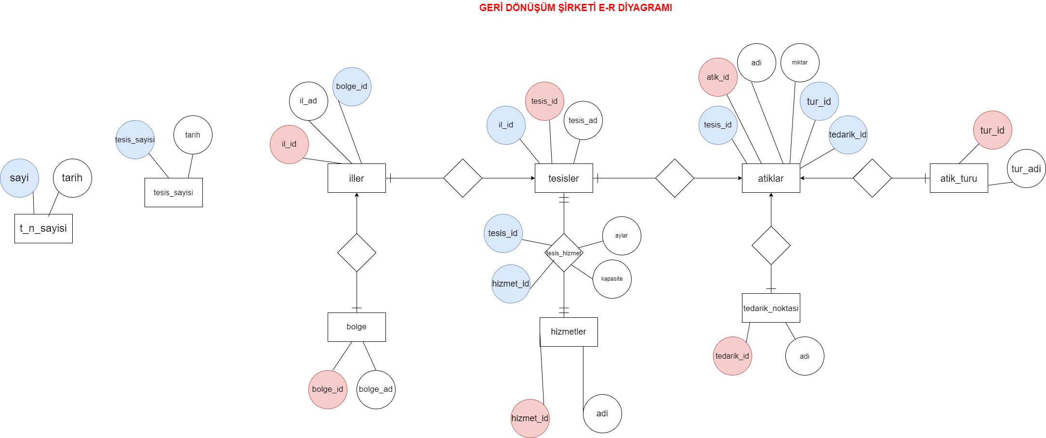

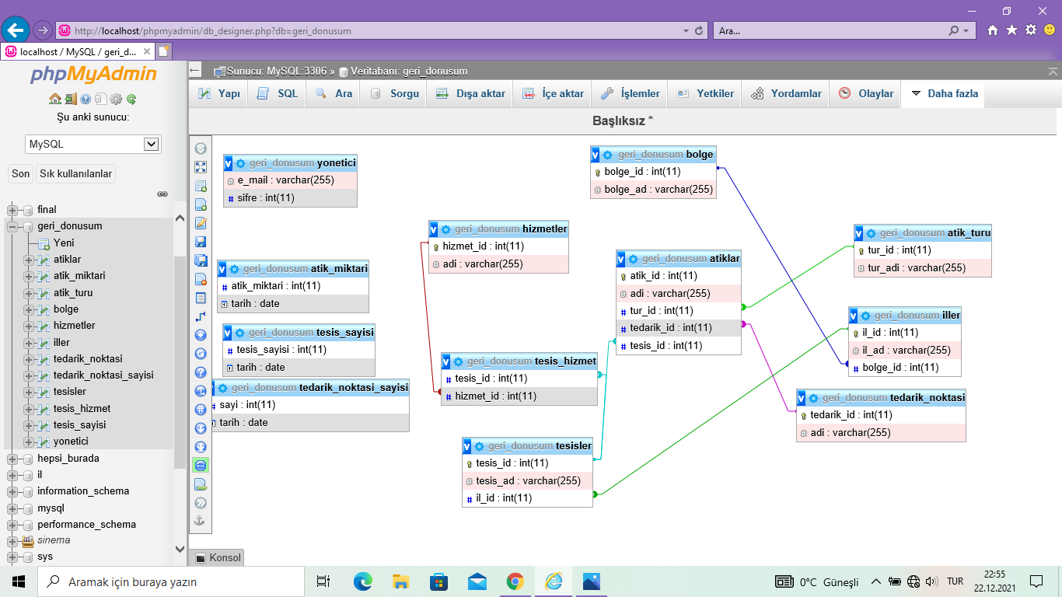

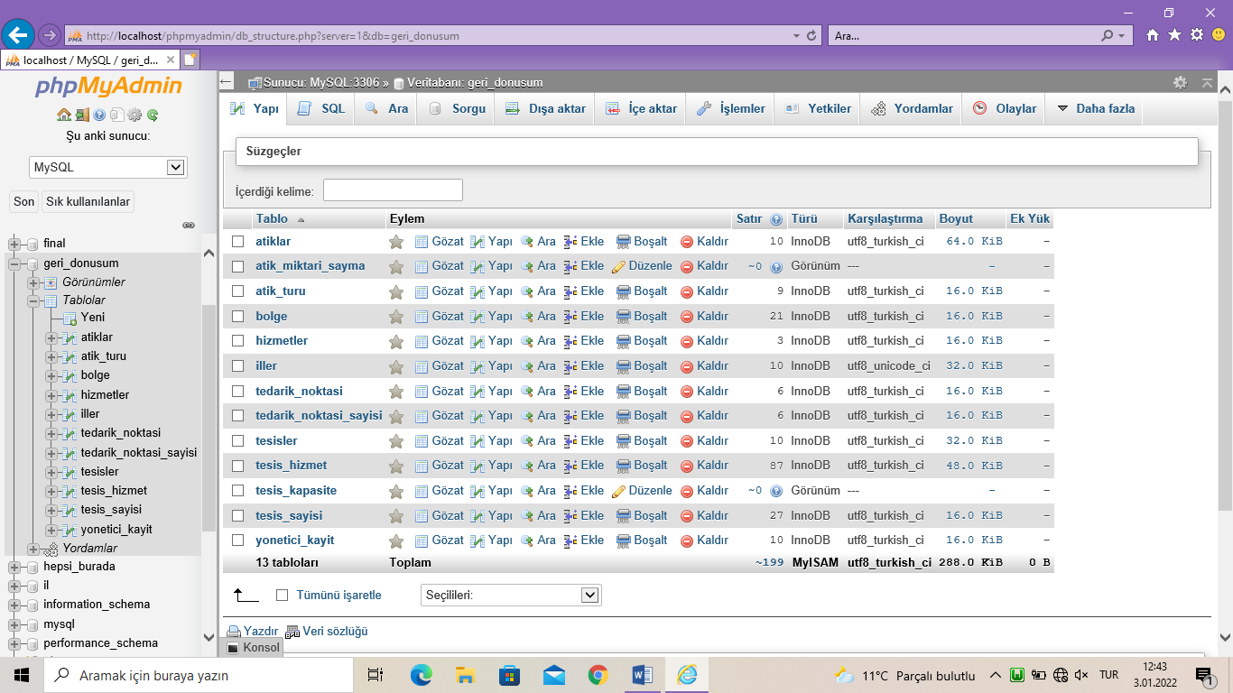

**YORDAMLAR:**

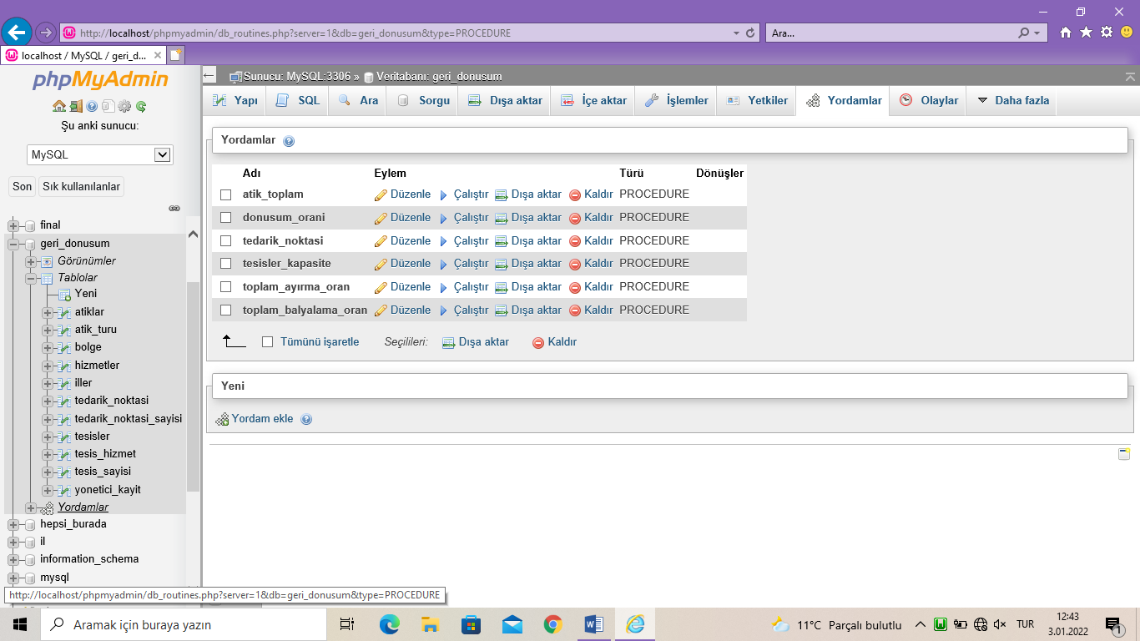

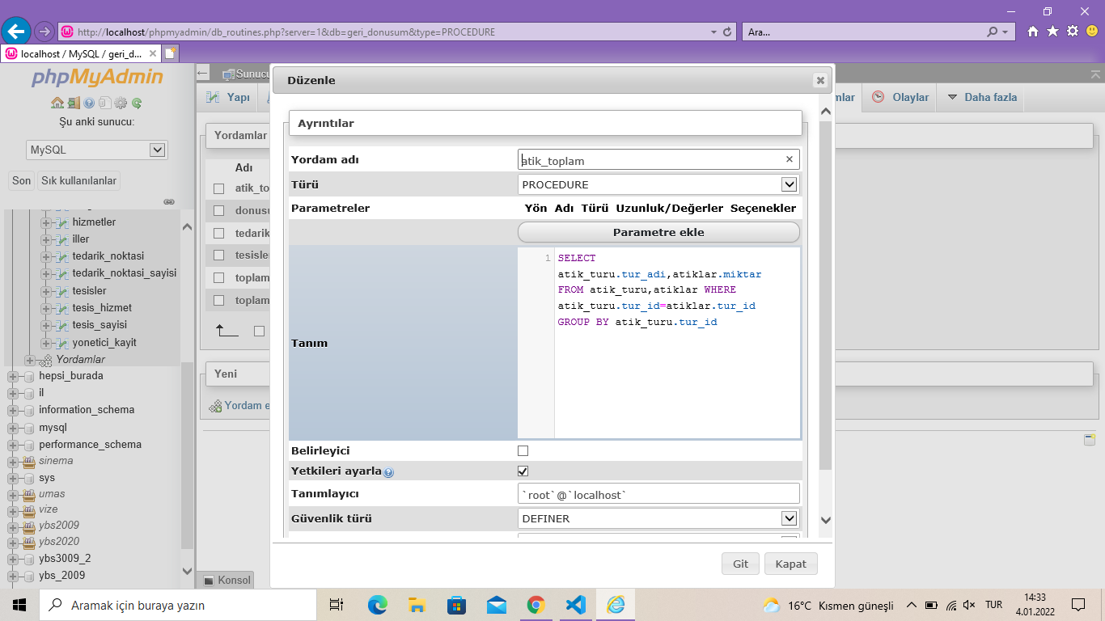

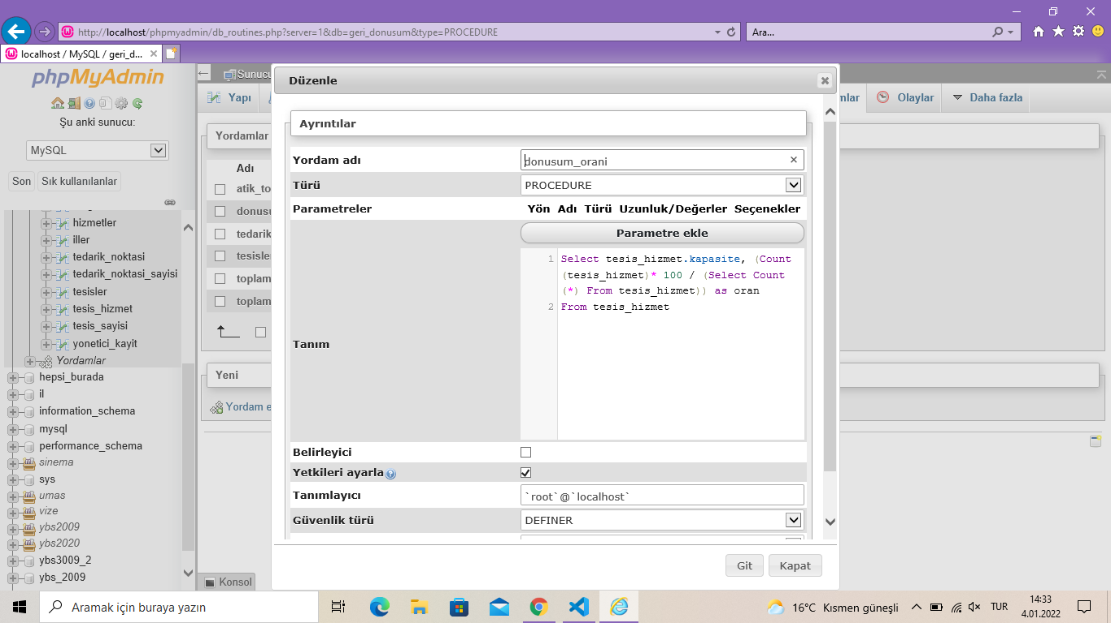

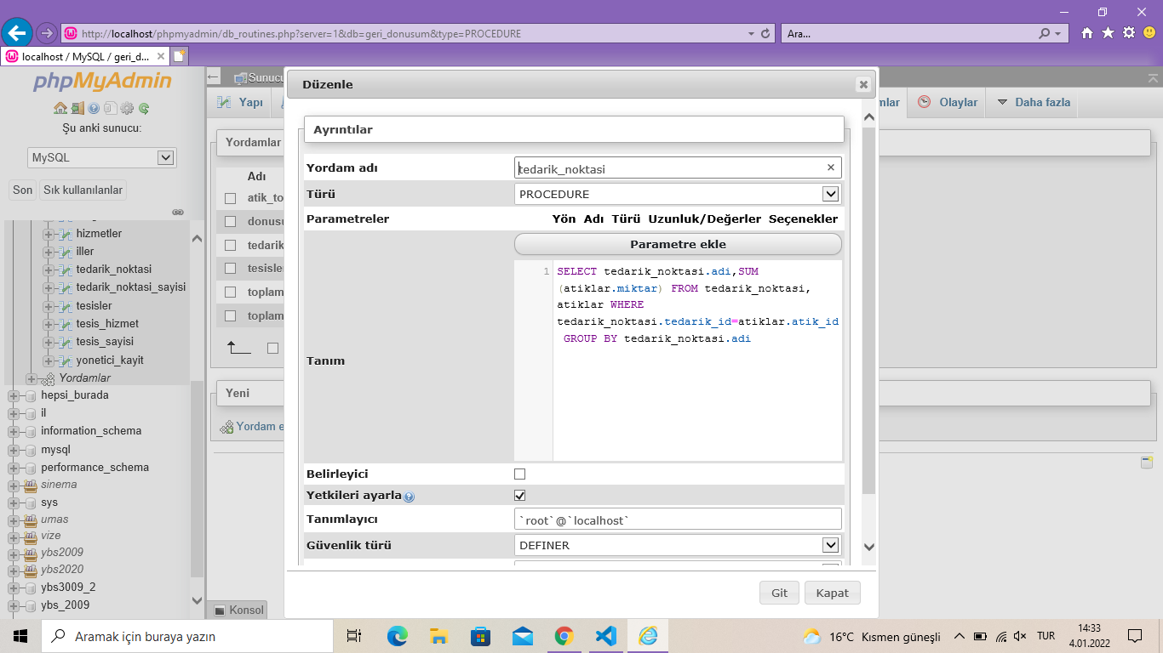

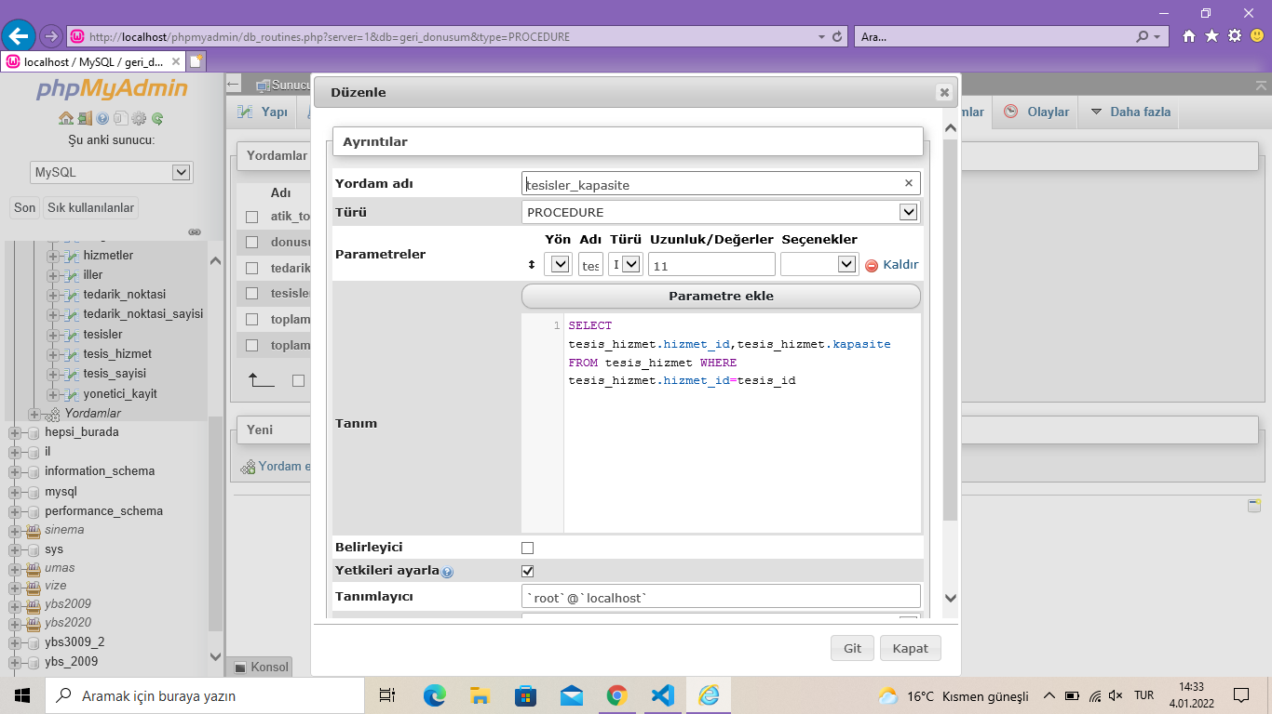

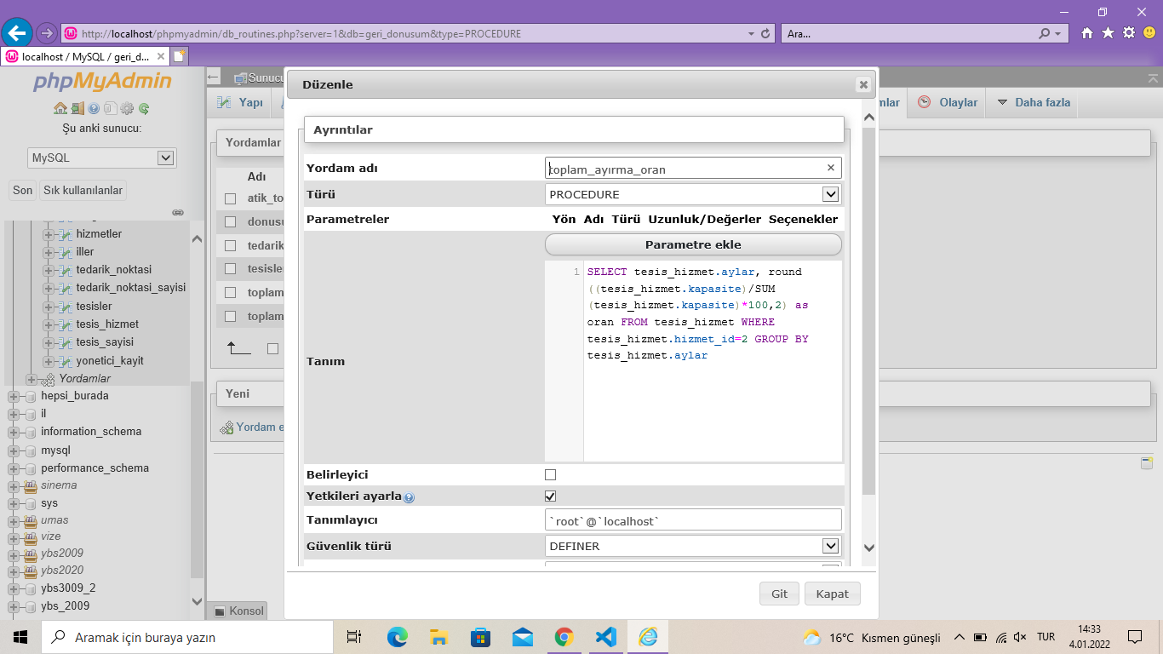

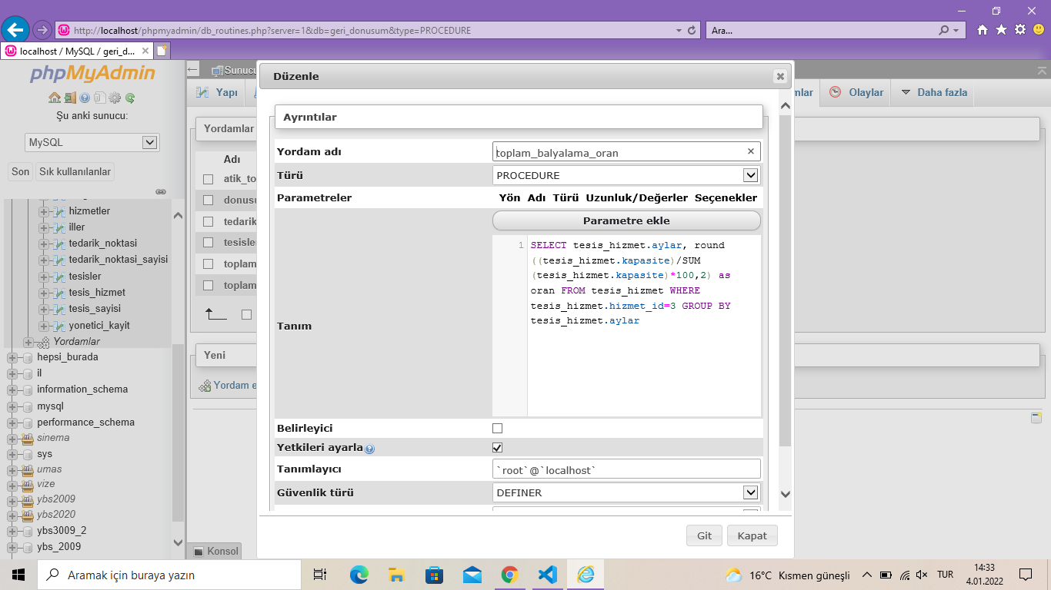

**VİEW:**

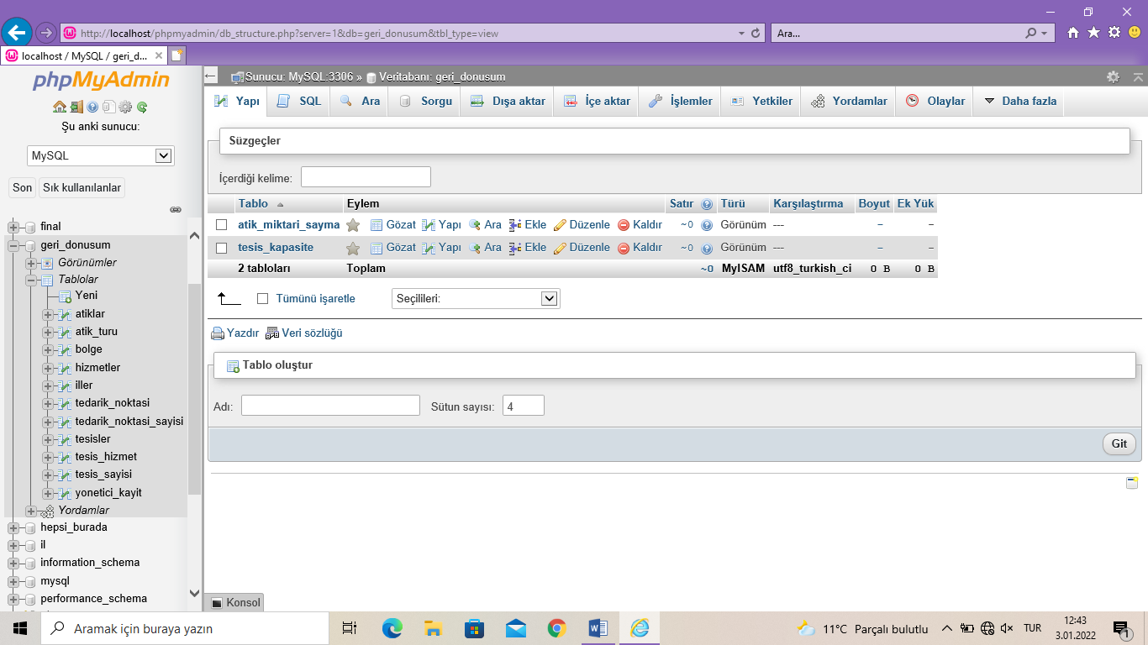

**TETİKLEYİCİLER:**

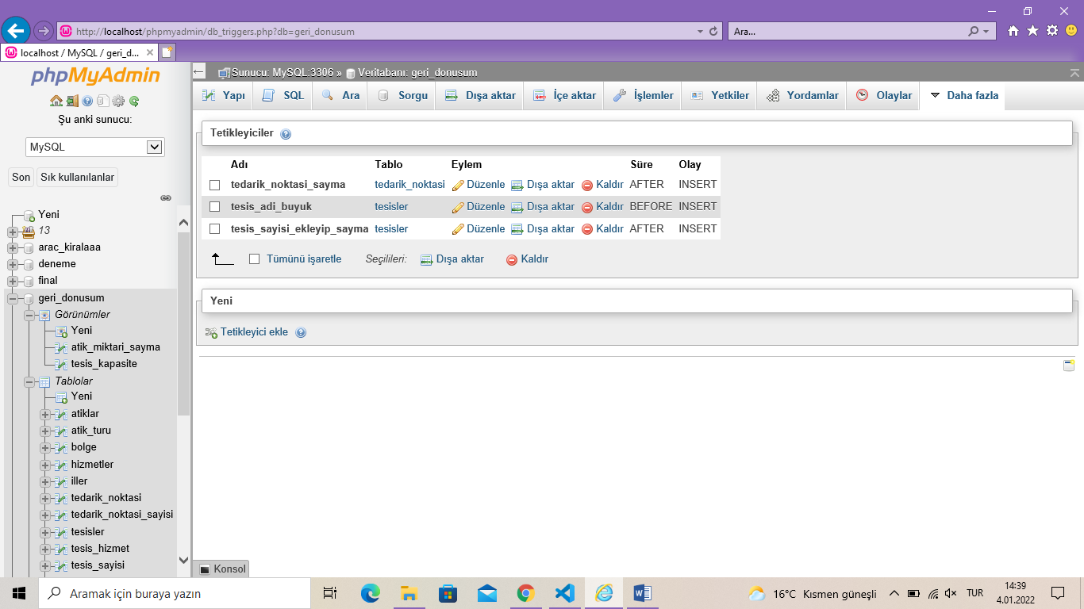

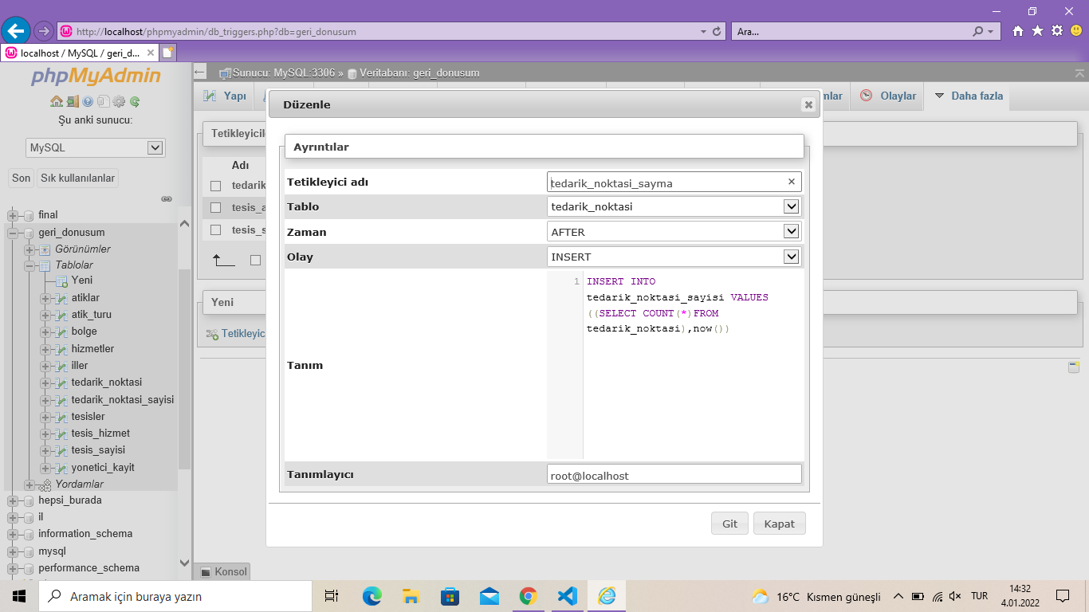

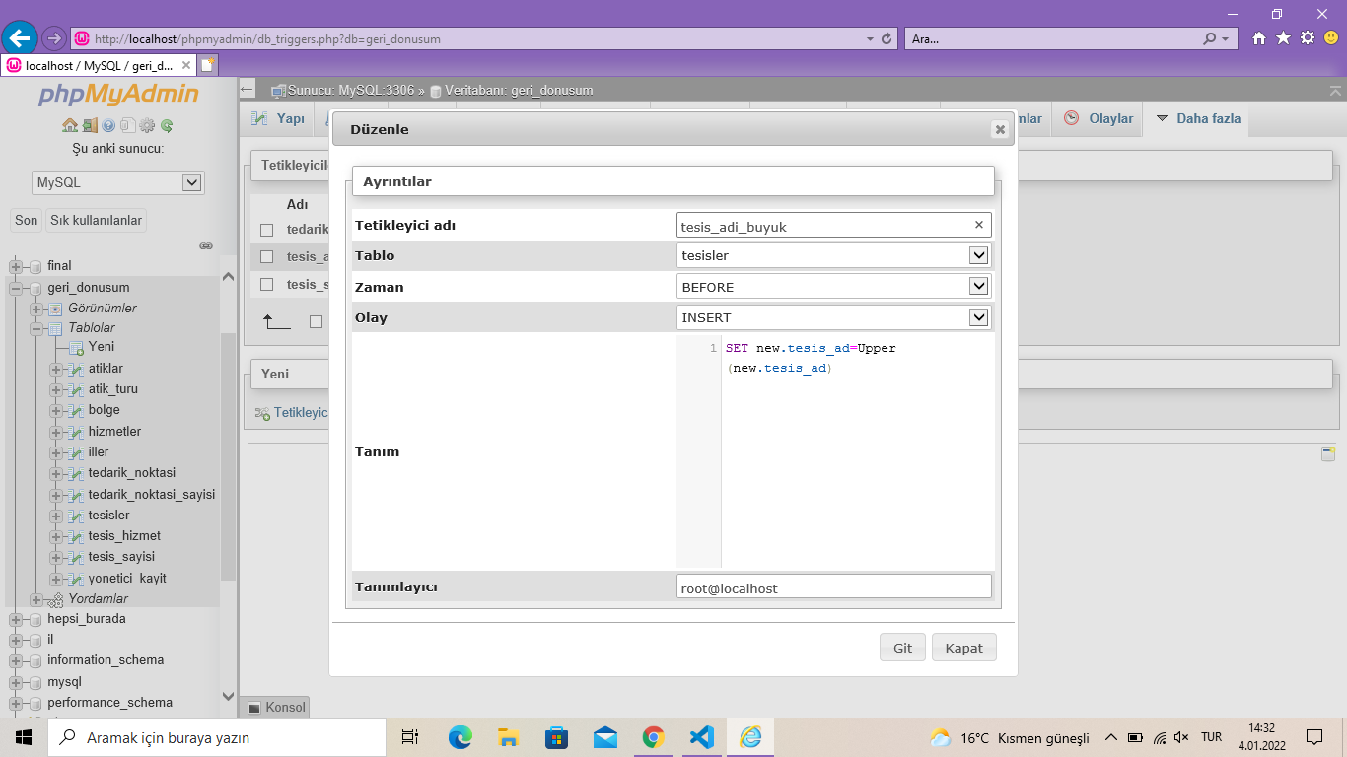

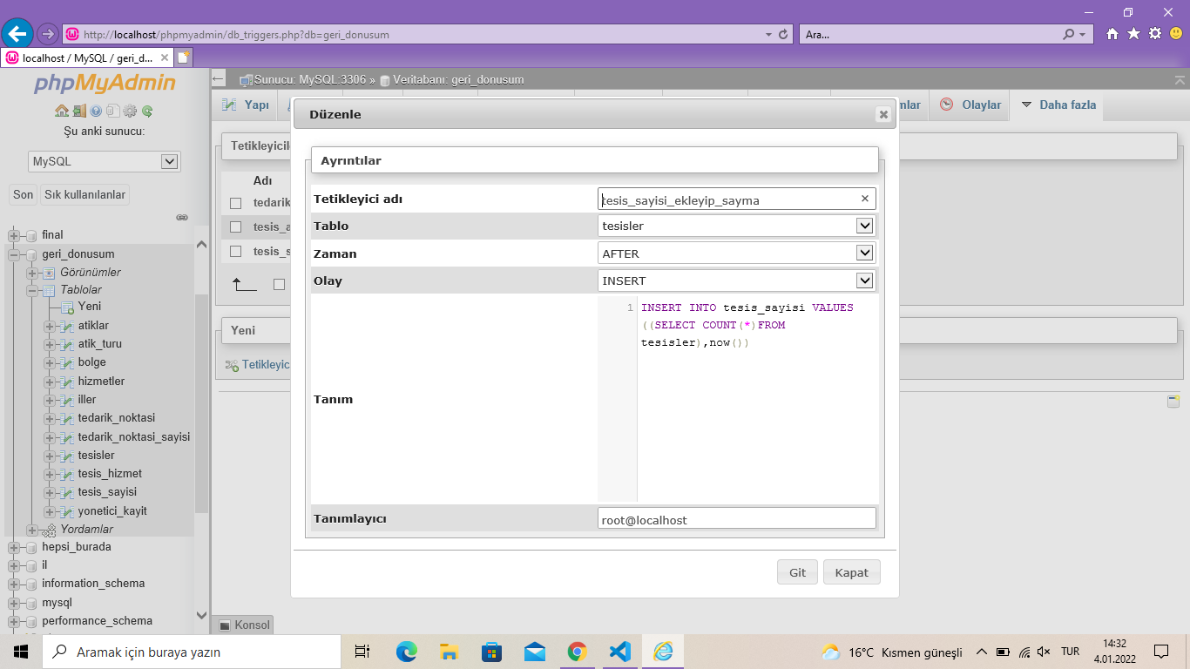

**TABLOLAR:**

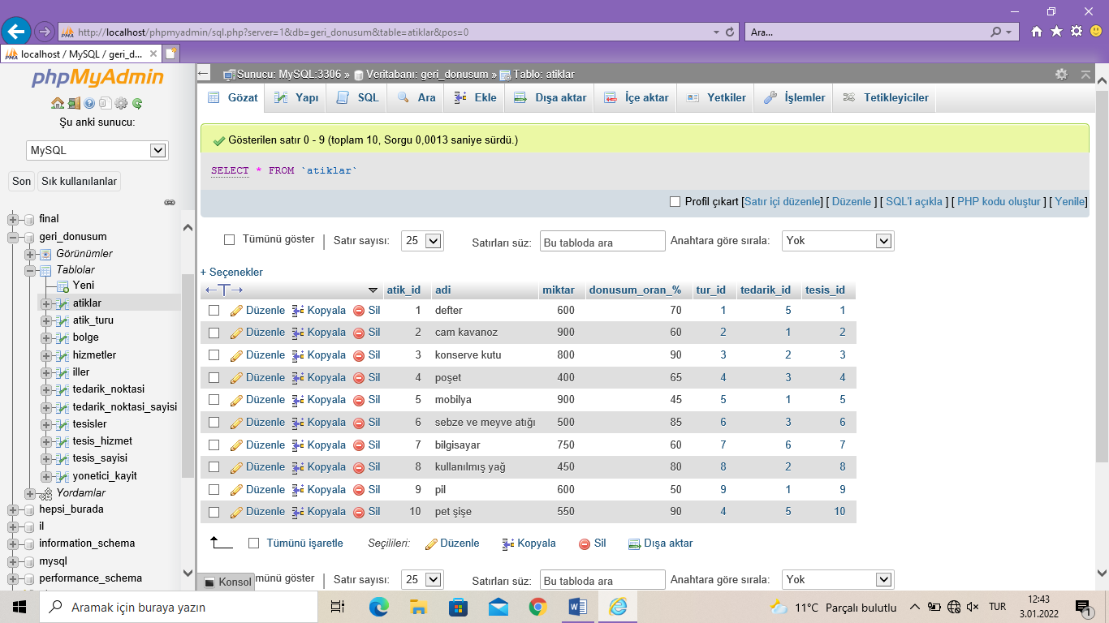

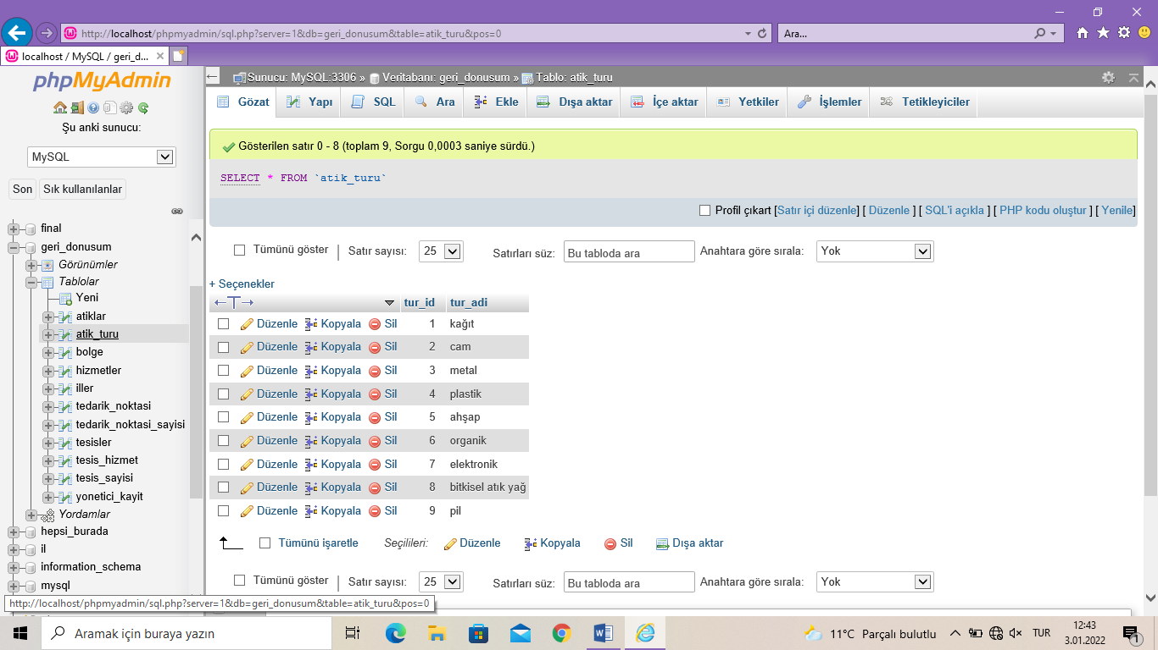

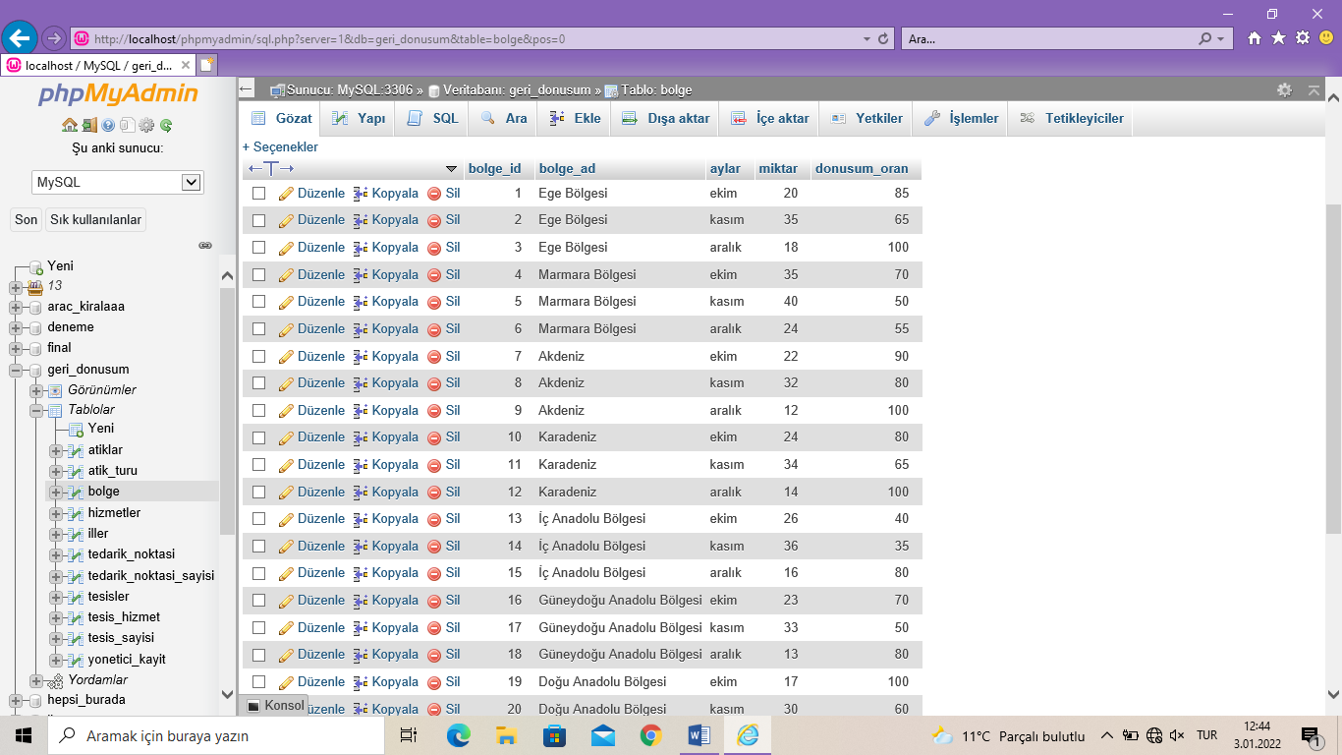

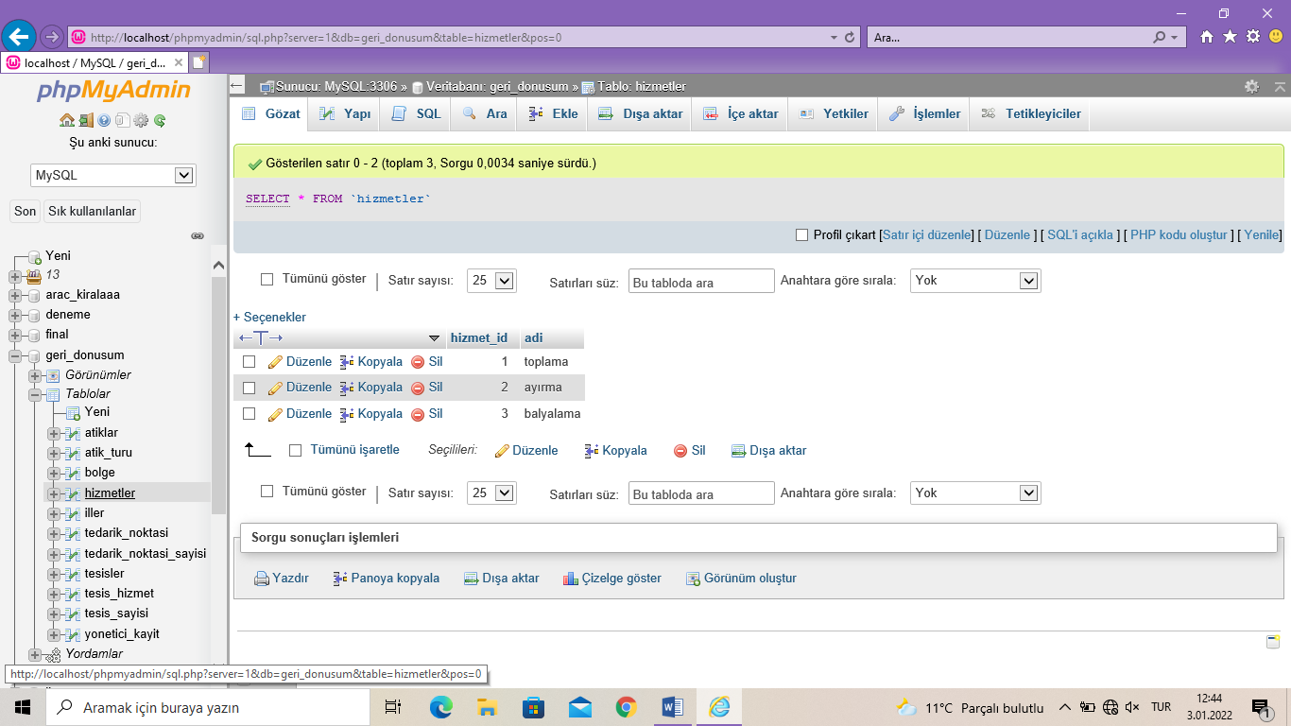

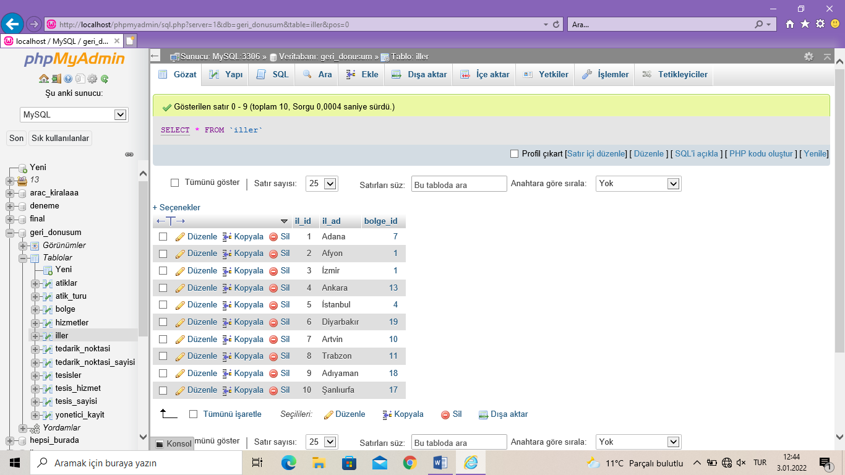

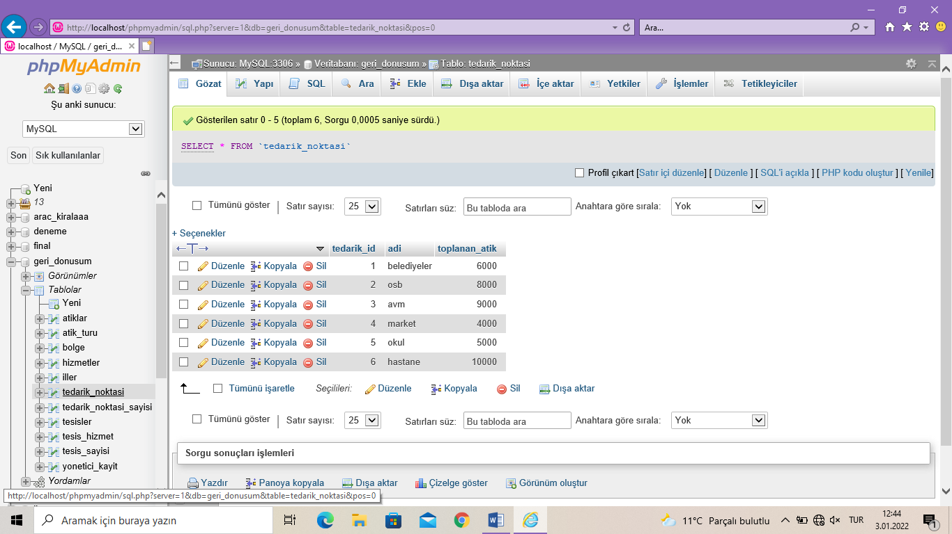

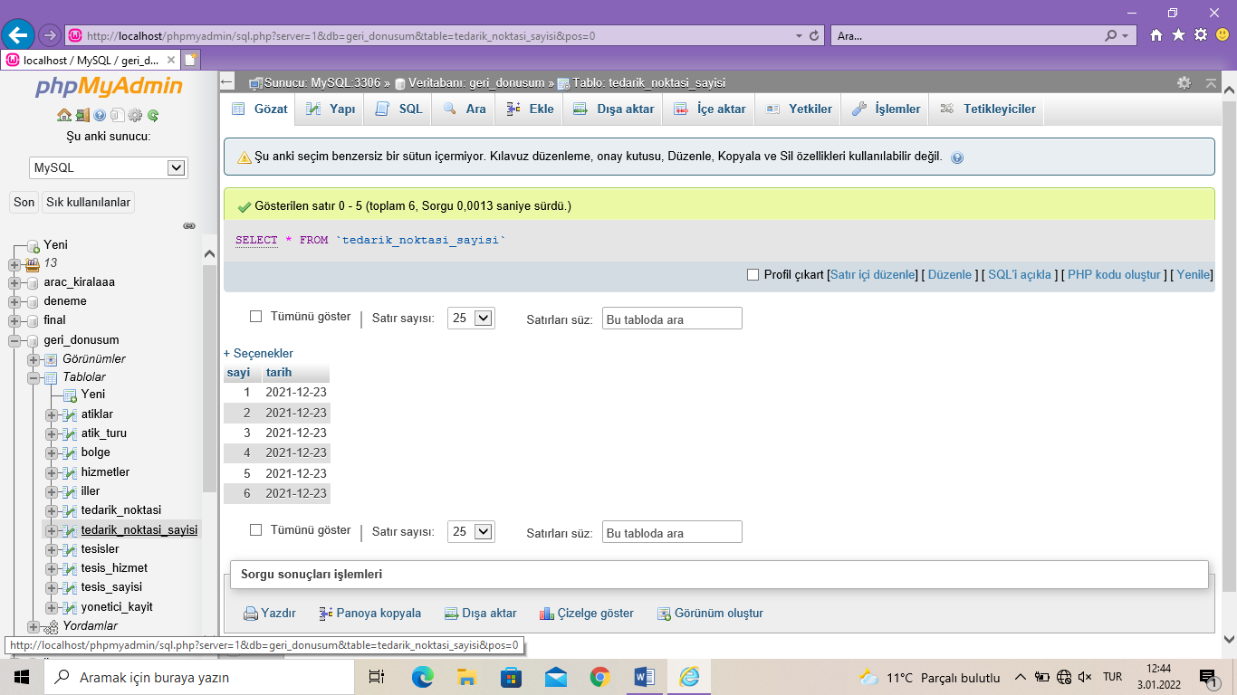

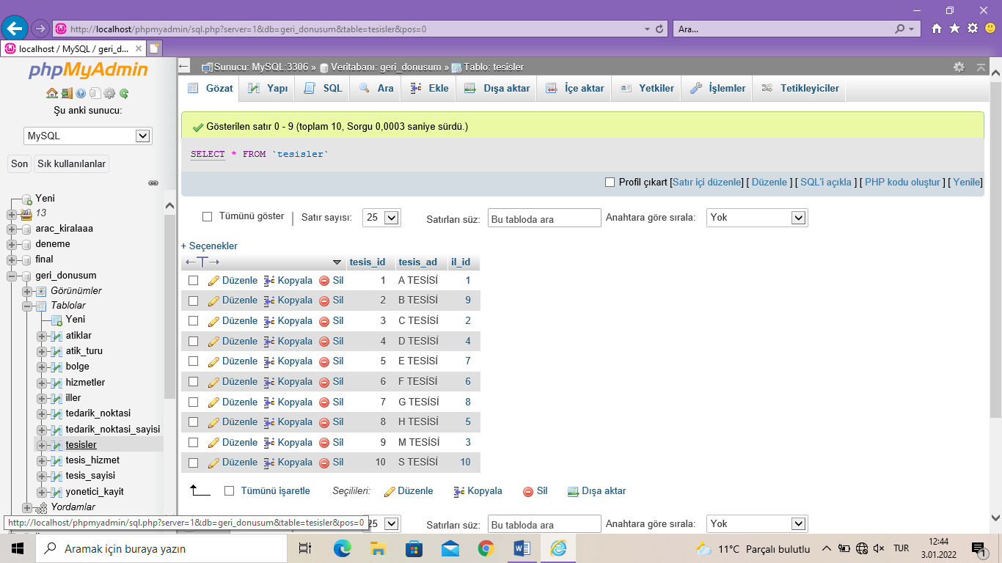

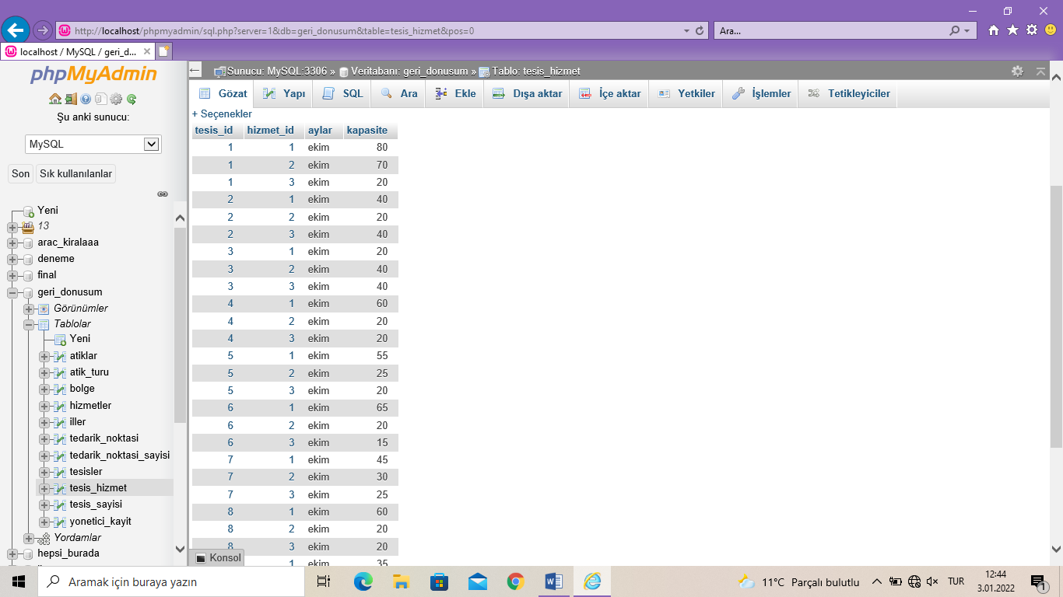

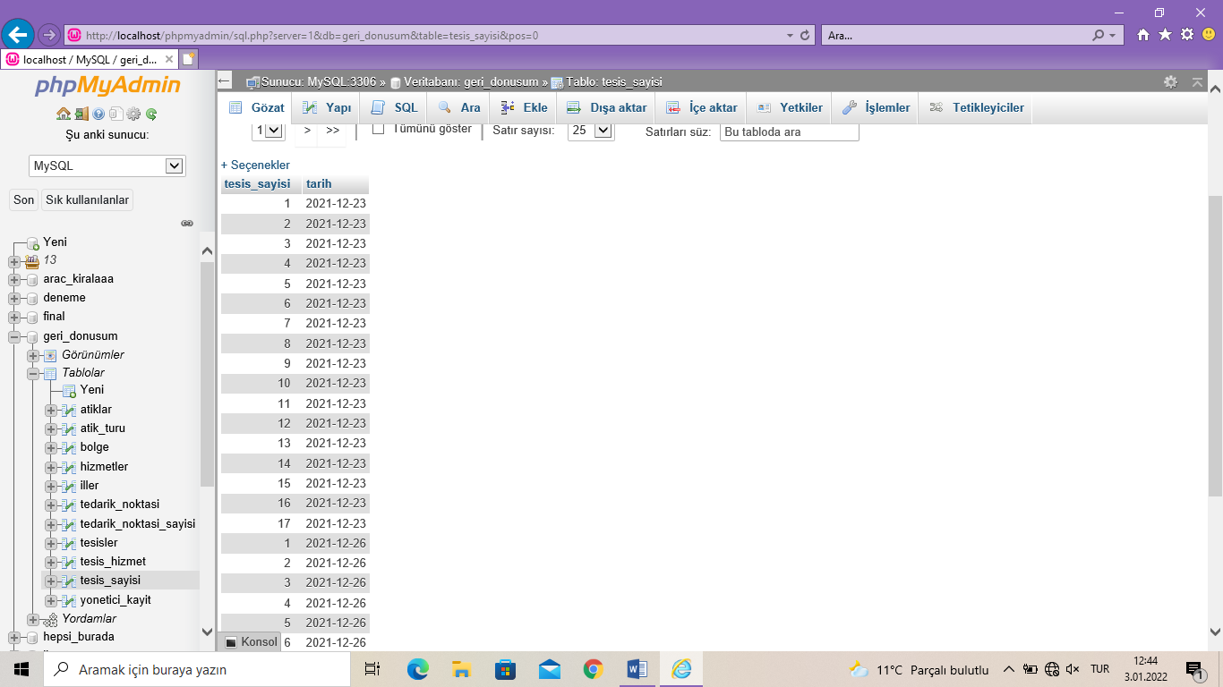

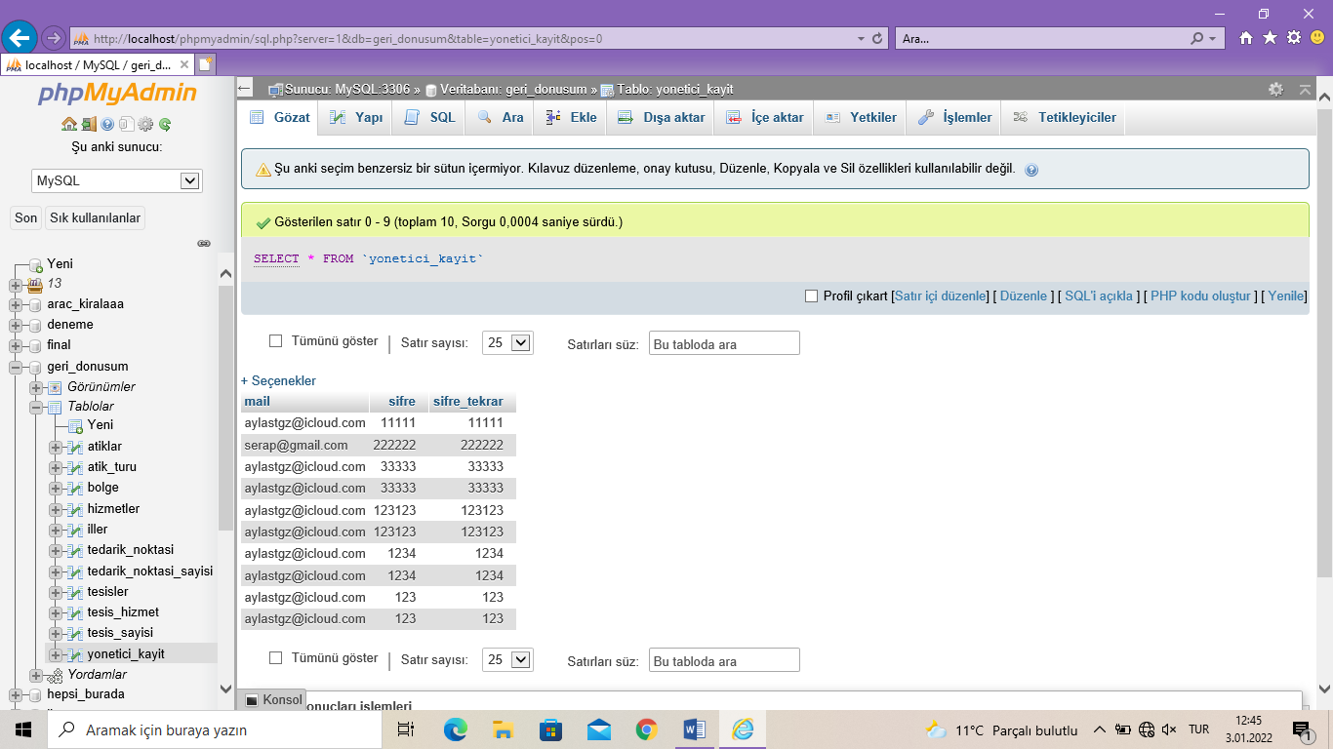

**3. Arayüz**

**Kayıt Ekranı:**

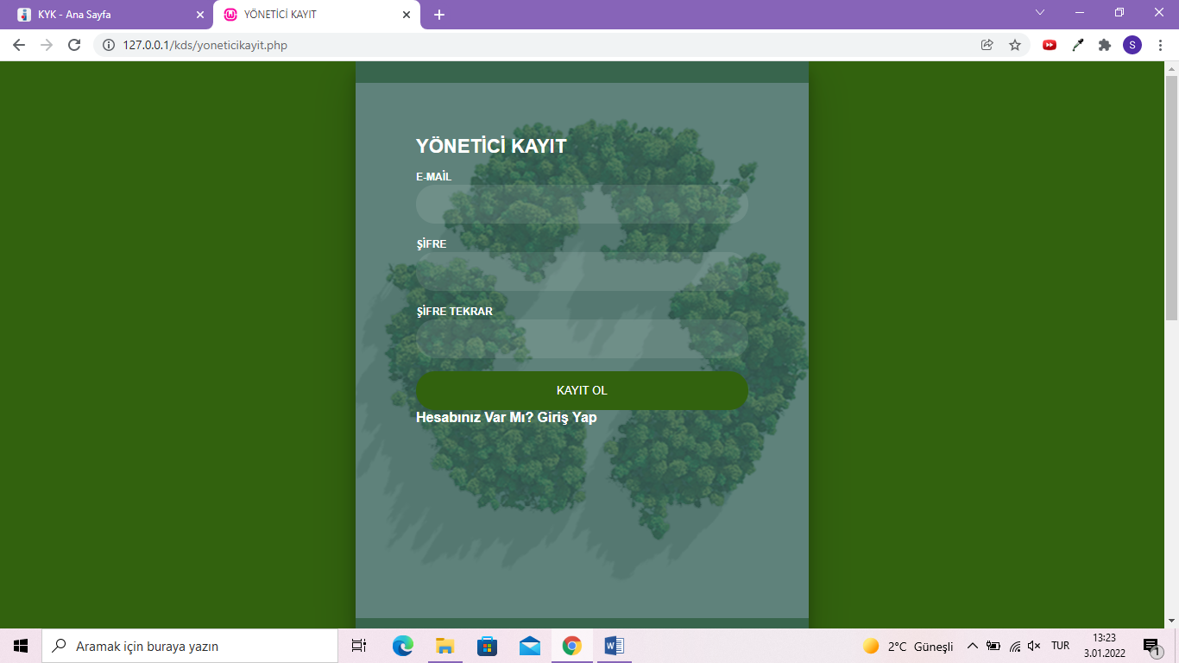

Kayıt ekranı ile yöneticilerin sisteme güvenli bir şekilde kaydolması sağlanmıştır.

**Giriş Ekranı:**

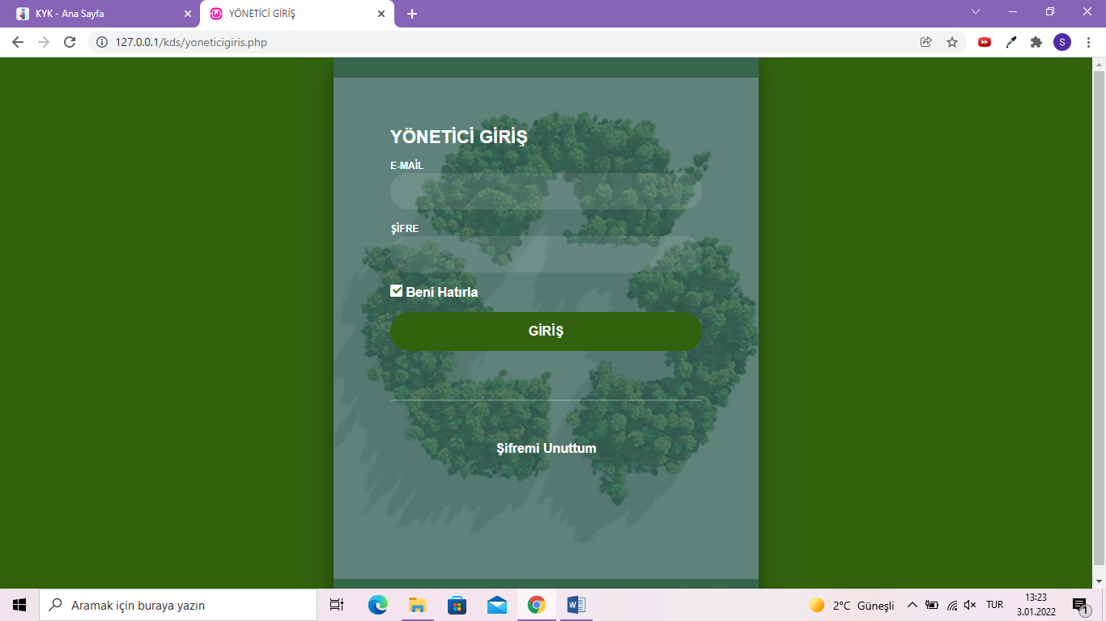

Bu giriş ekranı, kaydını tamamlayan yöneticilerin anasayfaya erişimini sağlayan giriş ekranıdır.

**Yönetici Ana Sayfası:**

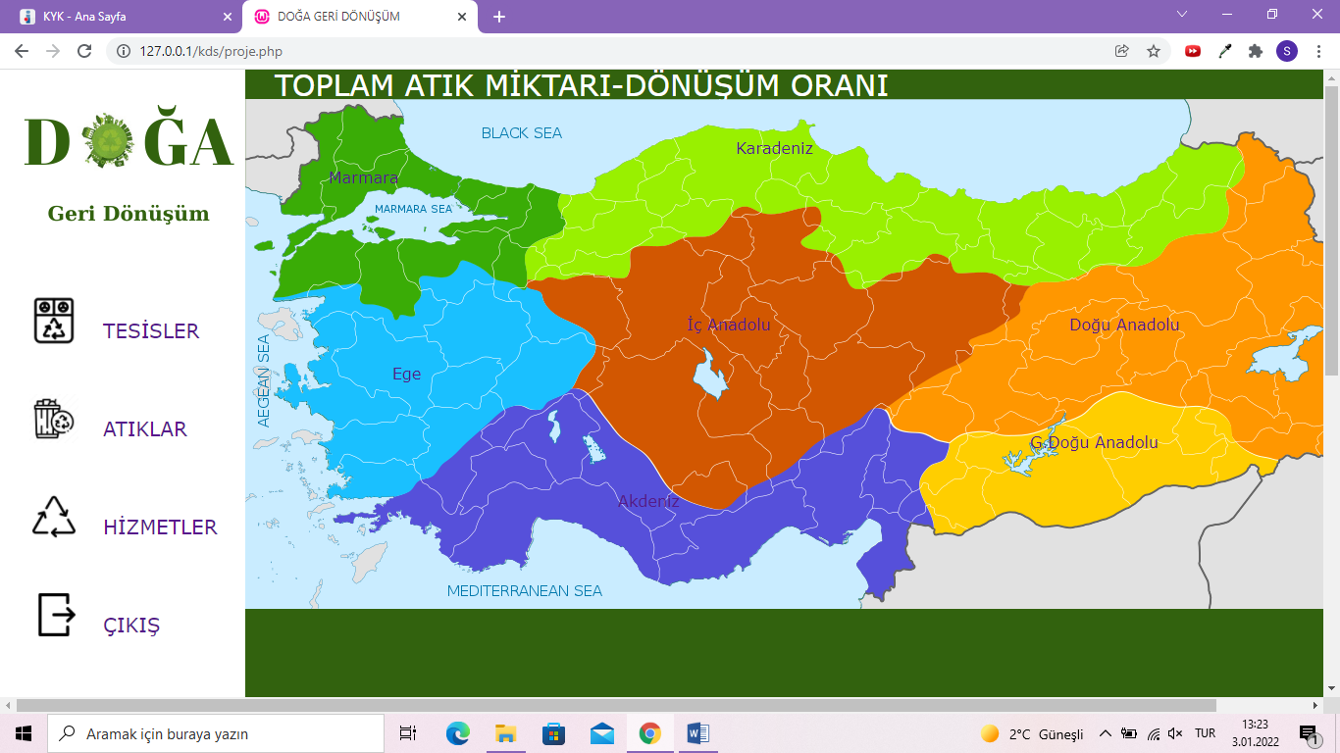

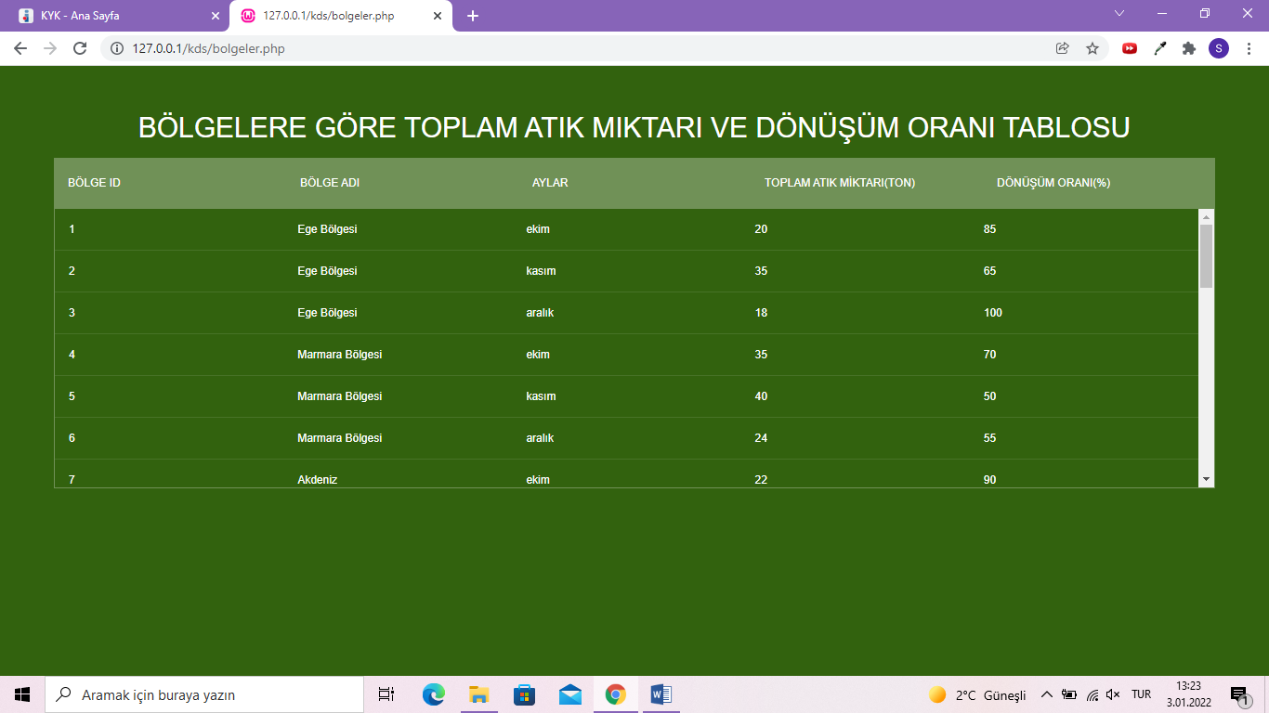

Yöneticiler, sisteme giriş yaptıktan sonra ana sayfaya yönlendirilmektedir. Anasayfa da bölgelerin bulunduğu bir harita bulunmaktadır. Yönetici istediği bölgeye tıklayaak bu bölgede bulunan tesislerde toplam atık miktarı ve dönüşüm oranını yüzdesel olarak görebilmekte.

**Tesisler Paneli:**

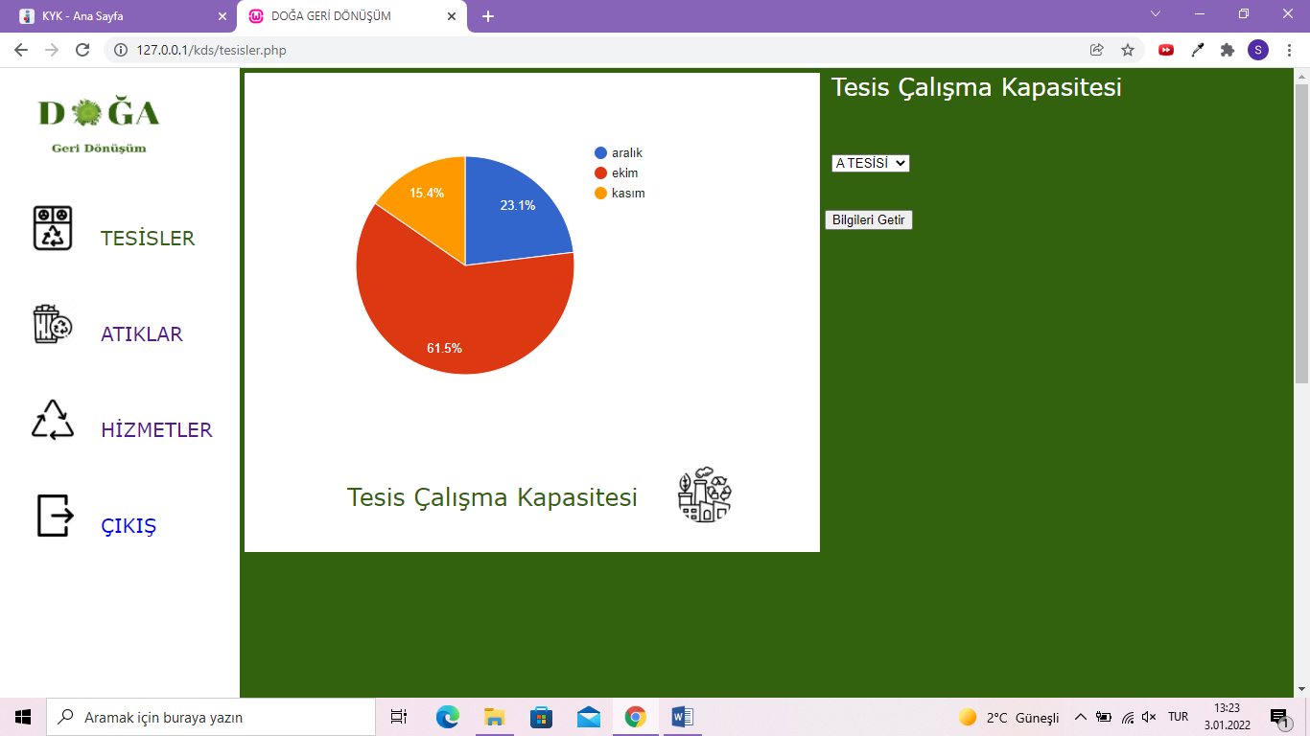

Bu panelde yönetici veri tabanında bulunan tesislerden istediğini seçerek tesisin ekim kasım ve aralık aylarına göre çalışma kapasitesini görebilmektedir.

**Atıklar Paneli:**

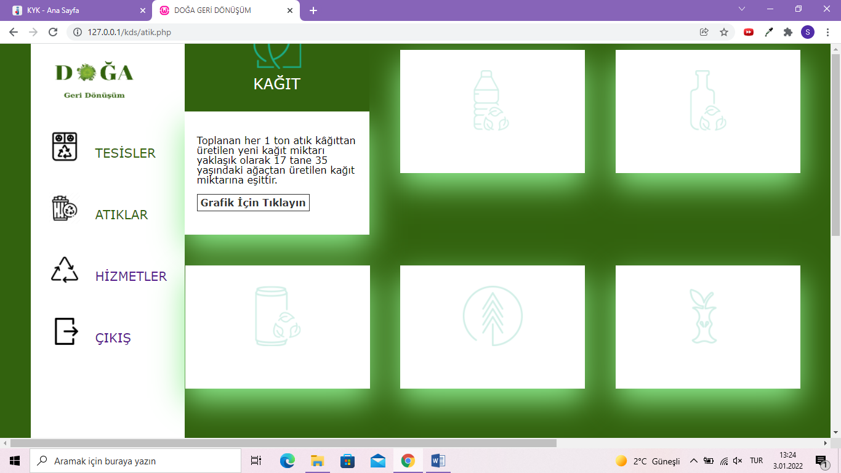

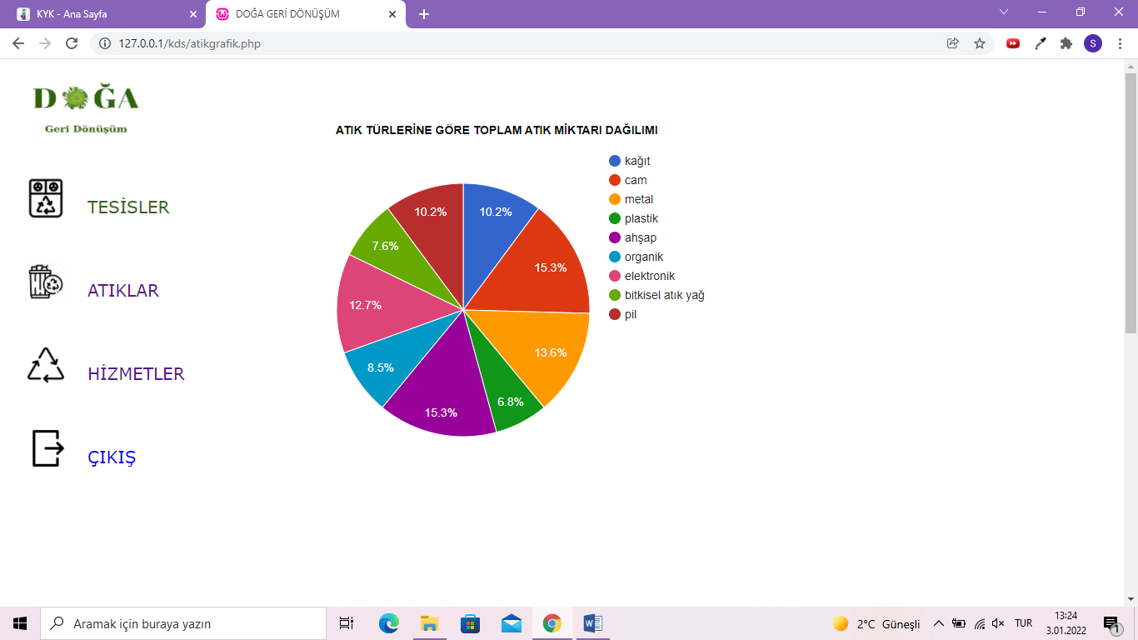

Bu panelde kağıt, plastik, cam, metal, ahşap, organik, elektronik, bitkisel atık yağ, pil gibi 9 adet atık türü bulunmaktadır. Bu atık türlerinden herhangi biri üzerine tıklayarak toplanan atıkların hangi atık türüne ait olduğunu ve miktarını gösteren bir pie chart bulunmakta.

**Hizmetler Paneli:**

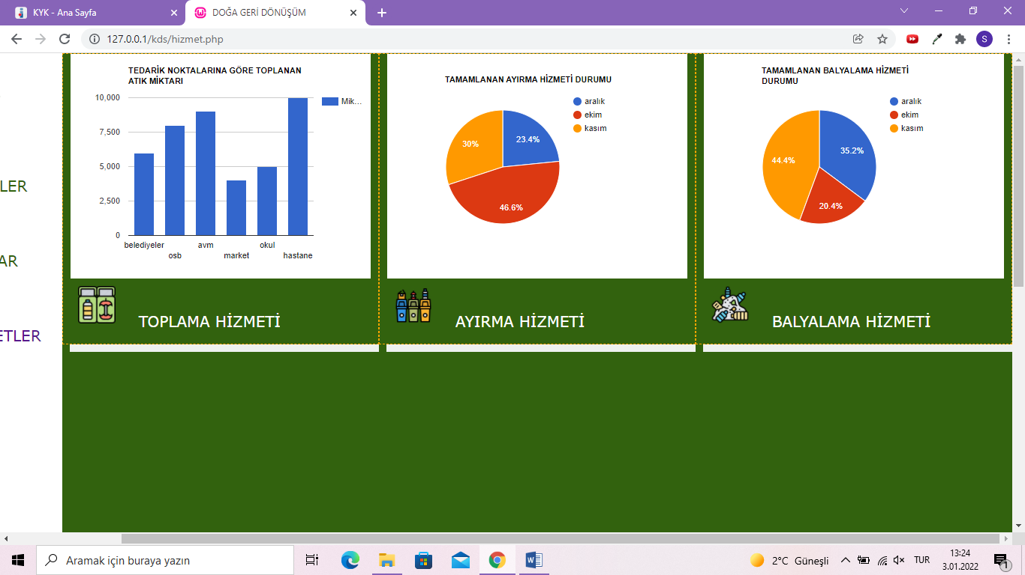

Bu panelde üç adet hizmet türü bulunmaktadır. Bunlar; toplama, ayırma, balyalama. Toplama kısmında atıkların toplandığı tedarik noktaları ve hangi tedarik noktasından ne kadar atık toplanmış bunu gösteren bir column chart bulunmaktadır. Ayırma ve Balyalama kısmında toplanan u atıkların ne kadarı ayrılmış ne kadarı balyalanmış ekim, kasım ve aralık aylarına göre gösteren bir pie chart bulunmaktadır.

**4. Kodlama Aşaması**

**Kullanılan Yazılım Dilleri:**

Front-End

- HTML

- CSS

- JavaScript

Back-End

- PHP

**Kullanılan Yazılım Programları:**

- Visual Studio Code

-Wampserver

**Yönetici Kayıt Kodlar:**

<!DOCTYPE html>

<html lang="tr" >

<head>

  <meta charset="UTF-8">

  <title>YÖNETİCİ KAYIT</title>

<div class="login-wrap">

    <div class="login-html">

    <form action="yoneticikayit.php" method="POST">

        <input id="tab-1" type="radio" name="tab" class="sign-in" checked><label for="tab-1" class="tab">YÖNETİCİ KAYIT</label>

        <div class="login-form">

            <div class="sign-in-htm">

                <div class="group">

                    <label for="mail" class="label">E-Mail</label>

                    <input id="mail" name="mail" type="text"  class="input" >

                </div>

                <div class="group">

                    <label for="sifre" class="label">Şifre</label>

                    <input id="sifre" name="sifre" type="password" class="input" data-type="password">

                </div>

        <div class="group">

                    <label for="sifre_tekrar" class="label">Şifre Tekrar</label>

                    <input id="sifre_tekrar" name="sifre_tekrar" type="password" class="input" data-type="password">

                </div>

                <div class="group">

                <input type="submit" class="btn" name="gönder" value="Kayıt Ol">

      <class="message1">Hesabınız Var Mı? <a href="yoneticigiris.php">Giriş Yap</a>

                </div>

                </div>

            </div>

        </div>

    </div>

</div>

<?php

include("girisbaglanti.php");

$servername= "localhost";

$username= "root";

$password="";

$dbname="geri_donusum";

$connect = new mysqli($servername,$username,$password,$dbname);

if($connect->connect_error) {

    die ("Bağlantı hatası oluştu");

}

$mail = $_POST["mail"];

$sifre = $_POST["sifre"];

$sifre_tekrar = $_POST["sifre_tekrar"];

$ekle = "INSERT INTO yonetici_kayit(mail,sifre,sifre_tekrar) VALUES('$mail','$sifre','$sifre_tekrar')";

    if($connect->query($ekle)) {

        echo "kayıt yapıldı";

    }

    else {

    echo "kayıt yapılamadı";

    }

?>

<style>

body{

    margin:0;

    color:white;

    background:#32620e;

    font:600 16px/18px 'Open Sans',sans-serif;

}

*,:after,:before{box-sizing:border-box}

.clearfix:after,.clearfix:before{content:'';display:table}

.clearfix:after{clear:both;display:block}

a{color:inherit;text-decoration:none}

.login-wrap{

    width:100%;

    margin:auto;

    max-width:525px;

    min-height:670px;

    position:relative;

    background:url("resim/agac.png") no-repeat center;

    box-shadow:0 12px 15px 0 rgba(0,0,0,.24),0 17px 50px 0 rgba(0,0,0,.19);

}

.login-html{

    width:100%;

    height:100%;

    position:absolute;

    padding:90px 70px 50px 70px;

    background:rgba(57,101,92, 0.8);

}

.login-html .sign-in-htm,

{

    top:0;

    left:0;

    right:0;

    bottom:0;

    position:absolute;

    transform:rotateY(180deg);

    backface-visibility:hidden;

    transition:all .4s linear;

}

.login-html .sign-in,

.login-form .group .check{

    display:none;

}

.login-html .tab,

.login-form .group .label,

.login-form .group .btn{

    text-transform:uppercase;

}

.login-html .tab{

    font-size:22px;

    margin-right:15px;

    padding-bottom:5px;

    margin:0 15px 10px 0;

    display:inline-block;

    border-bottom:2px solid transparent;

}

.login-form{

    min-height:345px;

    position:relative;

    perspective:1000px;

    transform-style:preserve-3d;

}

.login-form .group{

    margin-bottom:15px;

}

.login-form .group .label,

.login-form .group .input,

.login-form .group .btn{

    width:100%;

    color:white;

    display:block;

}

.login-form .group .input,

.login-form .group .btn{

    border:none;

    padding:15px 20px;

    border-radius:25px;

    background:rgba(255,255,255,.1);

}

.login-form .group input[data-type="sifre"]{

    text-security:circle;

    -webkit-text-security:circle;

}

.login-form .group .label{

    color:white;

    font-size:12px;

}

.login-form .group .btn{

    background:#32620e;

}

.login-form .group label .icon{

    width:15px;

    height:15px;

    border-radius:2px;

    position:relative;

    display:inline-block;

    background:#32620e;

}

.login-form .group label .icon:before,

.login-form .group label .icon:after{

    content:'';

    width:10px;

    height:2px;

    background:#32620e;

    position:absolute;

    transition:all .2s ease-in-out 0s;

}

.login-form .group label .icon:before{

    left:3px;

    width:5px;

    bottom:6px;

    transform:scale(0) rotate(0);

}

.login-form .group label .icon:after{

    top:6px;

    right:0;

    transform:scale(0) rotate(0);

}

.login-form .group .check:checked + label{

    color:white;

}

.login-form .group .check:checked + label .icon{

    background:white;

}

.login-form .group .check:checked + label .icon:before{

    transform:scale(1) rotate(45deg);

}

.login-form .group .check:checked + label .icon:after{

    transform:scale(1) rotate(-45deg);

}

.login-html .sign-in:checked + .tab + .sign-up + .tab + .login-form .sign-in-htm{

    transform:rotate(0);

}

.login-html .sign-up:checked + .tab + .login-form .sign-up-htm{

    transform:rotate(0);

}

.hr{

    height:2px;

    margin:60px 0 50px 0;

    background:rgba(255,255,255,.2);

}

.foot-lnk{

    text-align:center;

}

</style>

</head>

</html>

<?php

$servername= "localhost";

$username= "root";

$password="";

$dbname="geri_donusum";

$connect = new mysqli($servername,$username,$password,$dbname);

if($connect->connect_error) {

    die ("Bağlantı hatası oluştu");

}

$mail = $_POST["mail"];

$sifre = $_POST["sifre"];

$sifre_tekrar = $_POST["sifre_tekrar"];

$ekle = "INSERT INTO yonetici_kayit(mail,sifre,sifre_tekrar) VALUES('$mail','$sifre','$sifre_tekrar')";

    if($connect->query($ekle)) {

        echo "kayıt yapıldı";

    }

    else {

    echo "kayıt yapılamadı";

    }

?>

**Yönetici Giriş Kodlar:**

<!DOCTYPE html>

<html lang="tr" >

<head>

  <meta charset="UTF-8">

  <title>YÖNETİCİ GİRİŞ</title>

<div class="login-wrap">

    <div class="login-html">

    <form action="yoneticigiris.php" method="POST">

        <input id="tab-1" type="radio" name="tab" class="sign-in" checked><label for="tab-1" class="tab">YÖNETİCİ GİRİŞ</label>

        <div class="login-form">

            <div class="sign-in-htm">

                <div class="group">

                    <label for="e_mail" class="label">E-Mail</label>

                    <input id="e_mail" name="e_mail" type="text"  class="input" >

                </div>

                <div class="group">

                    <label for="sifre" class="label">Şifre</label>

                    <input id="sifre" name="sifre" type="password" class="input" data-type="password">

                </div>

                <div class="group">

                    <input id="check" type="checkbox" class="check" checked>

                    <label for="check"><span class="icon"></span> Beni Hatırla</label>

                </div>

                <div class="group">

                    <a href="proje.php" class="button"  style="text-align:center;">GİRİŞ</a>

                    <ul class="tab-group">

                </div>

                <div class="hr"></div>

                <div class="foot-lnk">

                    <a href="#forgot">Şifremi Unuttum</a>

                </div>

            </div>

        </div>

    </div>

</div>

<style>

body{

    margin:0;

    color:white;

    background:#32620e;

    font:600 16px/18px 'Open Sans',sans-serif;

}

*,:after,:before{box-sizing:border-box}

.clearfix:after,.clearfix:before{content:'';display:table}

.clearfix:after{clear:both;display:block}

a{color:inherit;text-decoration:none}

.login-wrap{

    width:100%;

    margin:auto;

    max-width:525px;

    min-height:670px;

    position:relative;

    background:url("resim/agac.png") no-repeat center;

    box-shadow:0 12px 15px 0 rgba(0,0,0,.24),0 17px 50px 0 rgba(0,0,0,.19);

}

.login-html{

    width:100%;

    height:100%;

    position:absolute;

    padding:90px 70px 50px 70px;

    background:rgba(57,101,92, 0.8);

}

.login-html .sign-in-htm,

{

    top:0;

    left:0;

    right:0;

    bottom:0;

    position:absolute;

    transform:rotateY(180deg);

    backface-visibility:hidden;

    transition:all .4s linear;

}

.login-html .sign-in,

.login-form .group .check{

    display:none;

}

.login-html .tab,

.login-form .group .label,

.login-form .group .button{

    text-transform:uppercase;

}

.login-html .tab{

    font-size:22px;

    margin-right:15px;

    padding-bottom:5px;

    margin:0 15px 10px 0;

    display:inline-block;

    border-bottom:2px solid transparent;

}

.login-html .sign-in:checked + .tab,

{

    color:#32620e;

    border-color:#32620e;

}

.login-form{

    min-height:345px;

    position:relative;

    perspective:1000px;

    transform-style:preserve-3d;

}

.login-form .group{

    margin-bottom:15px;

}

.login-form .group .label,

.login-form .group .input,

.login-form .group .button{

    width:100%;

    color:white;

    display:block;

}

.login-form .group .input,

.login-form .group .button{

    border:none;

    padding:15px 20px;

    border-radius:25px;

    background:rgba(255,255,255,.1);

}

.login-form .group input[data-type="sifre"]{

    text-security:circle;

    -webkit-text-security:circle;

}

.login-form .group .label{

    color:white;

    font-size:12px;

}

.login-form .group .button{

    background:#32620e;

}

.login-form .group label .icon{

    width:15px;

    height:15px;

    border-radius:2px;

    position:relative;

    display:inline-block;

    background:#32620e;

}

.login-form .group label .icon:before,

.login-form .group label .icon:after{

    content:'';

    width:10px;

    height:2px;

    background:#32620e;

    position:absolute;

    transition:all .2s ease-in-out 0s;

}

.login-form .group label .icon:before{

    left:3px;

    width:5px;

    bottom:6px;

    transform:scale(0) rotate(0);

}

.login-form .group label .icon:after{

    top:6px;

    right:0;

    transform:scale(0) rotate(0);

}

.login-form .group .check:checked + label{

    color:white;

}

.login-form .group .check:checked + label .icon{

    background:white;

}

.login-form .group .check:checked + label .icon:before{

    transform:scale(1) rotate(45deg);

}

.login-form .group .check:checked + label .icon:after{

    transform:scale(1) rotate(-45deg);

}

.login-html .sign-in:checked + .tab + .sign-up + .tab + .login-form .sign-in-htm{

    transform:rotate(0);

}

.login-html .sign-up:checked + .tab + .login-form .sign-up-htm{

    transform:rotate(0);

}

.hr{

    height:2px;

    margin:60px 0 50px 0;

    background:rgba(255,255,255,.2);

}

.foot-lnk{

    text-align:center;

}

</style>

</head>

</html>

**Anasayfa Kodlar:**

<!DOCTYPE html>

<html>

<head>

<title> DOĞA GERİ DÖNÜŞÜM</title>

<meta charset="UTF-8"/>

<meta name="Description" content="DOĞA GERİ DÖNÜŞÜM"/>

<meta name="googlebot" content="noarchive"/>

<meta name="Revisit-After" content="7 days"/>

<meta name="copyright" content="2021-2022 Copyright | http://www.doga.com.tr/tr/ " />

<link rel="stylesheet" href="reset.css">

<link rel="stylesheet" href="page.css">

<body>

<div class="cerceve">

    <div class="kenar">

    <img src="resim/logo1.png">

    <div class="panel">

        <img class="icon" src="resim/tesis.png">

       <span class="span"><a href="tesisler.php">TESİSLER</a></span>

    </div>

    <div class="panel">

        <img class="icon" src="resim/atik.png">

        <span class="span"><a href="atik.php">ATIKLAR</a></span>

    </div>

    <div class="panel">

        <img class="icon" src="resim/hizmet.png">

        <span class="span"><a href="hizmet.php">HİZMETLER</a></span>

    </div>

    <div class="panel">

        <img class="icon" src="resim/cikis.png">

        <span class="span"><a href="cikis.php">ÇIKIŞ</a></span>

    </div>

    </div>

    <div class="icerik">

        <body>

            <div class="container">

            <span class="kutuYazi">TOPLAM ATIK MİKTARI-DÖNÜŞÜM ORANI</span>

            <div class="harita">

            <img src="resim/harita.png">

                    <a href="bolgeler.php" class="state marmara">Marmara</a>

                    <a href="bolgeler.php" class="state ege">Ege</a>

                    <a href="bolgeler.php" class="state karadeniz">Karadeniz</a>

                    <a href="bolgeler.php" class="state icanadolu">İç Anadolu</a>

                    <a href="bolgeler.php" class="state doguanadolu">Doğu Anadolu</a>

                    <a href="bolgeler.php" class="state akdeniz">Akdeniz</a>

                    <a href="bolgeler.php" class="state gdoguanadolu">G.Doğu Anadolu</a>

                </div>

            </div>

</body>

            </div>

        </div>

    </div>

    </div>

</div>

</body>

</head>

</html>

<style>

     a {

     text-decoration: none;

    }

.kutuYazi{

    color: white;

    margin:30px;

    font-size:30px;

}

.img{

  width:500px;

  position:absolute;

}

.state{

  z-index:10;

  position:absolute;

  display:block;

}

.marmara{

  margin-top:-450px;

  margin-left:85px;

}

.ege{

  margin-top:-250px;

  margin-left:150px;

}

.karadeniz{

  margin-top:-480px;

  margin-left:500px;

}

.icanadolu{

  margin-top:-300px;

  margin-left:450px;

}

.akdeniz{

  margin-top:-120px;

  margin-left:380px;

}

.gdoguanadolu{

  margin-top:-180px;

  margin-left:800px;

}

.doguanadolu{

  margin-top:-300px;

  margin-left:840px;

}

</style>

**Anasayfa Bölgeler Tablo Kodlar:**

<html>

<section>

  <h1>Bölgelere Göre Toplam Atık Miktarı ve Dönüşüm Oranı Tablosu</h1>

  <div class="tbl-header">

    <table cellpadding="0" cellspacing="0" border="0">

      <thead>

        <tr>

          <th>BÖLGE ID</th>

          <th>BÖLGE ADI</th>

          <th>AYLAR</th>

          <th>TOPLAM ATIK MİKTARI(ton)</th>

          <th>DÖNÜŞÜM ORANI(%)</th>

        </tr>

      </thead>

    </table>

  </div>

  <div class="tbl-content">

    <table cellpadding="0" cellspacing="0" border="0">

      <tbody>

<?php

    $sorgu= "SELECT bolge.bolge_id, bolge.bolge_ad, bolge.aylar, bolge.miktar, bolge.donusum_oran FROM bolge";

    $baglanti=mysqli_connect("localhost","root","","geri_donusum"); mysqli_set_charset($baglanti, "utf8");

    $sonuc= $baglanti->query($sorgu);

    while($satir= $sonuc->fetch_assoc())

    {

        echo"<tr>";

        echo"<td>".$satir{"bolge_id"}."</td>";

        echo"<td>".$satir{"bolge_ad"}."</td>";

        echo"<td>".$satir{"aylar"}."</td>";

        echo"<td>".$satir{"miktar"}."</td>";

        echo"<td>".$satir{"donusum_oran"}."</td>";

        echo"</tr>";

    }

?>

          <tr class="satır">

          <td>1</td>

          <td>Ege Bölgesi</td>

          <td>eylül</td>

          <td>9</td>

          <td>100</td>

        </tr>

        <tr class="satır">

          <td></td>

          <td></td>

          <td></td>

          <td></td>

          <td></td>

        </tr>

        <tr class="satır">

          <td></td>

          <td></td>

          <td></td>

          <td></td>

          <td></td>

        </tr>

        <tr class="satır">

          <td></td>

          <td></td>

          <td></td>

          <td></td>

          <td></td>

        </tr>

        <tr class="satır">

          <td></td>

          <td></td>

          <td></td>

          <td></td>

          <td></td>

        </tr>

        <tr class="satır">

          <td></td>

          <td></td>

          <td></td>

          <td></td>

          <td></td>

        </tr>

        <tr class="satır">

          <td></td>

          <td></td>

          <td></td>

          <td></td>

          <td></td>

        </tr>

      </tbody>

    </table>

  </div>

</section>

</html>

<style>

a {

     text-decoration: none;

    }

h1{

  font-size: 30px;

  color: #fff;

  text-transform: uppercase;

  font-weight: 300;

  text-align: center;

  margin-bottom: 15px;

}

table{

  width:100%;

  table-layout: fixed;

}

.tbl-header{

  background-color: rgba(255,255,255,0.3);

 }

.tbl-content{

  height:300px;

  overflow-x:auto;

  margin-top: 0px;

  border: 1px solid rgba(255,255,255,0.3);

}

th{

  padding: 20px 15px;

  text-align: left;

  font-weight: 500;

  font-size: 12px;

  color: #fff;

  text-transform: uppercase;

}

td{

  padding: 15px;

  text-align: left;

  vertical-align:middle;

  font-weight: 300;

  font-size: 12px;

  color: #fff;

  border-bottom: solid 1px rgba(255,255,255,0.1);

}

body{

  background: #32620e;

  background: #32620e;

  font-family: 'Roboto', sans-serif;

}

section{

  margin: 50px;

}

</style>

<!DOCTYPE html>

    <style>

        table {

          border-collapse: collapse;

          width: 40%;

        }

        th, td {

          text-align: left;

          padding: 8px;

        }

        th{

            background-color: #4CAF50;

            color: white;

        }

        tr:nth-child(even) {background-color: #f2f2f2;}

    </style>

    <?php //include("baglan.php");

    $dbAd='geri_donusum';

    $dbKullanici='root';

    $dbSifre='';

    $db=new PDO('mysql:host=localhost;charset=utf8;dbname='.$dbAd,$dbKullanici,$dbSifre);

    $atik=$db-&gt;query("SELECT * FROM atiklar ORDER BY atik_id ASC",PDO::FETCH_ASSOC);

    echo "&lt;table&gt;";

    echo "&lt;tr&gt;";

    echo "&lt;th&gt;ID&lt;/th&gt;";

    echo "&lt;th&gt;AD&lt;/th&gt;";

    echo "&lt;th&gt;MİKTAR&lt;/th&gt;";

    echo "&lt;/tr&gt;";

    foreach($atik as $atiklar )

    {

       echo "&lt;tr&gt;";

       echo "&lt;td&gt;",$atiklar['id'],"&lt;/td&gt;";

       echo "&lt;td&gt;",$atiklar['ad'],"&lt;/td&gt;";

       echo "&lt;td&gt;",$atiklar['miktar'],"&lt;/td&gt;";

       echo "&lt;/tr&gt;";

    }

    ?>

    </html>

**Tesisler Paneli Kodlar:**

<!DOCTYPE html>

<html>

<head>

<title> DOĞA GERİ DÖNÜŞÜM</title>

<meta charset="UTF-8"/>

<meta name="Description" content="DOĞA GERİ DÖNÜŞÜM"/>

<meta name="googlebot" content="noarchive"/>

<meta name="Revisit-After" content="7 days"/>

<meta name="copyright" content="2021-2022 Copyright | http://www.doga.com.tr/tr/ " />

<link rel="stylesheet" href="reset.css">

<link rel="stylesheet" href="page.css">

<div class="cerceve">

    <div class="kenar">

      <a href="proje.php"><img class="logo" src="resim/logo1.png"></a>

    <div class="panel">

    <img class="icon" src="resim/tesis.png">

     <span class="span">TESİSLER</span>

    </div>

    <div class="panel">

        <img class="icon" src="resim/atik.png">

        <span class="span"><a href="proje.php">ATIKLAR</a></span>

    </div>

    <div class="panel">

        <img class="icon" src="resim/hizmet.png">

        <span class="span"><a href="proje.php">HİZMETLER</a></span>

    </div>

    <div class="panel">

        <img class="icon" src="resim/cikis.png">

        <span class="span"><a href="cıkıs.php">ÇIKIŞ</a></span>

    </div>

    </div>

    <div class="icerik">

            <div class="grafikKutu">

            <div id="chart_div"></div>

            <?php

$db= new PDO("mysql:host=localhost;dbname=geri_donusum;charset=utf8","root","");

$query=$db->query("SELECT tesis_hizmet.aylar,tesis_hizmet.kapasite FROM tesis_hizmet WHERE tesis_hizmet.hizmet_id=tesis_id GROUP BY tesis_hizmet.aylar");

    ?>

<html>

            <head>

    <!--Load the AJAX API-->

    <script type="text/javascript" src="https://www.gstatic.com/charts/loader.js"></script>

    <script type="text/javascript">

      // Load the Visualization API and the corechart package.

      google.charts.load('current', {'packages':['corechart']});

      // Set a callback to run when the Google Visualization API is loaded.

      google.charts.setOnLoadCallback(drawChart);

      // Callback that creates and populates a data table,

      // instantiates the pie chart, passes in the data and

      // draws it.

      function drawChart() {

        // Create the data table.

        var data = new google.visualization.DataTable();

        data.addColumn('string', 'Topping');

        data.addColumn('number', 'Slices');

        data.addRows([

            <?php

          foreach($query as $row){

            echo"['".$row["aylar"]."',".$row["kapasite"]."],";

          }

          ?>

        ]);

        // Set chart options

        var options = {'title':'',

                       'width':600,

                       'height':400};

        // Instantiate and draw our chart, passing in some options.

        var chart = new google.visualization.PieChart(document.getElementById('chart_div'));

        chart.draw(data, options);

      }

    </script>

  </head>

  </html>

                <span class="sembol">

                    <img class="sembolImg" src="resim/donusum.png">

                    </span>

                    <span class="kutuYazi">Tesis Çalışma Kapasitesi</span>

                     </div>

    </div>

    <div class="bilgiKutu">

    <div class="left2">

  <p><form action="tesisler.php" method="POST">

                <h1>Tesis Çalışma Kapasitesi</h1><br><br>

        <select name="section" >

                                        <?php

                                            $sorgu= "SELECT tesisler.tesis_ad FROM tesisler";

                                            $baglanti=mysqli_connect("localhost","root","","geri_donusum"); mysqli_set_charset($baglanti, "utf8");

                                            $sonuc= $baglanti->query($sorgu);

                                            while($yaz= $sonuc->fetch_assoc())

                                            {

                                                echo " <option value='".$yaz["tesis_ad"]."'>".$yaz["tesis_ad"]. "</option>";

                                            }

                                        ?>

                                        </select>

    </div>

</fieldset>

                <br><br>

                <input type="submit" id="tikla" value="Bilgileri Getir" name="gonder" onclick="myfunc()">

              </form>

              </p>

</div>

                </div>

        </div>

    </div>

    </div>

<style>

  a {

     text-decoration: none;

    }

    .cerceve {

    background: #32620e;

  }

  .urunBilgileri {

    background: #32620e;

    margin: 20px auto;

    color: white

    text-align:center;

    font-family: 'Times New Roman', Times, serif;

    font-size: large;

    font-style: italic;

  }

  .dikeyForm {

    background: white;

    padding: 40px;

    max-width: 400px;

    margin: 20px auto;

    border-radius: 2px;

    box-shadow: 0 4px 10px 4px rgba(19, 35, 47, 0.3);

  }

    .button {

    position: relative;

    right: -20px;

    top: 120px;

    background: white;

    padding: 20px;

    max-width: 200px;

    margin: 10px auto;

    border-radius: 2px;

    box-shadow: 0 4px 10px 4px rgba(19, 35, 47, 0.3);

    }

    .grafikKutu{

      width: 600px;

      height:500px;

      border: 5px solid #000;

      border-color:#32620e;

      background-color:white;

    }

    .sembolImg{

    width: 60px;

    height: 60px;

    margin: 100px;

    display: flex;

    align-items: center;

    justify-content: center;

    border-radius: 50px;

    position: relative;

    top: -90px;

    right:-350px;

    }

    .kutuYazi{

    color: #32620e;

    margin: 2px;

    font-size: 25px;

    padding: 5px;

    position: relative;

    top: -230px;

    right:-100px;

    }

  .left2{

    color:white;

    margin: 2px;

    font-size: 25px;

    padding: 5px;

  }

    </style>

</div>

</body>

</head>

</html>

<style>

**Atıklar Paneli Kodlar:**

<!DOCTYPE html>

<html>

<head>

<title> DOĞA GERİ DÖNÜŞÜM</title>

<meta charset="UTF-8"/>

<meta name="Description" content="DOĞA GERİ DÖNÜŞÜM"/>

<meta name="googlebot" content="noarchive"/>

<meta name="Revisit-After" content="7 days"/>

<meta name="copyright" content="2021-2022 Copyright | http://www.doga.com.tr/tr/ " />

<link rel="stylesheet" href="reset.css">

<link rel="stylesheet" href="page.css">

<script>

</script>

<body>

<div class="cerceve">

    <div class="kenar">

      <a href="proje.php"><img class="logo" src="resim/logo1.png"></a>

    <div class="panel">

    <img class="icon" src="resim/tesis.png">

     <span class="span">TESİSLER</span>

    </div>

    <div class="panel">

        <img class="icon" src="resim/atik.png">

        <span class="span">ATIKLAR</span>

    </div>

    <div class="panel">

        <img class="icon" src="resim/hizmet.png">

        <span class="span"><a href="hizmet.php">HİZMETLER</a></span>

    </div>

    <div class="panel">

        <img class="icon" src="resim/cikis.png">

        <span class="span"><a href="cikis.php">ÇIKIŞ</a></span>

    </div>

    </div>

    <div class="icerik">

    <body>

    <div class="container">

        <div class="card">

            <div class="face face1">

                <div class="content">

                    <img src="resim/kagit.png">

                    <h3>KAĞIT</h3>

                </div>

            </div>

            <div class="face face2">

                <div class="content">

                    <p>Toplanan her 1 ton atık kâğıttan üretilen yeni kağıt miktarı yaklaşık olarak 17 tane 35 yaşındaki ağaçtan üretilen kağıt miktarına eşittir.

</p>

                        <a href="atikgrafik.php">Grafik İçin Tıklayın</a>

                </div>

            </div>

        </div>

        <div class="card">

            <div class="face face1">

                <div class="content">

                    <img src="resim/plastik.png">

                    <h3>PLASTİK</h3>

                </div>

            </div>

            <div class="face face2">

                <div class="content">

                    <p>Yeni kaynaklar kullanarak plastikleri üretmek yerine plastik atıklardan faydalanarak geri-dönüşüm ürünler elde etmek % 85-90 oranında enerji tasarrufu sağlamaktadır.</p>

                        <a href="atikgrafik.php">Grafik İçin Tıklayın</a>

                </div>

            </div>

        </div>

        <div class="card">

            <div class="face face1">

                <div class="content">

                    <img src="resim/cam.png">

                    <h3>CAM</h3>

                </div>

            </div>

            <div class="face face2">

                <div class="content">

                    <p>Kullanılmış cam ambalajların geri kazanımıyla sera-gazı emisyonunda önemli azalma dolayısıyla yakıt tasarrufu sağlanmaktadır.</p>

                        <a href="atikgrafik.php">Grafik İçin Tıklayın</a>

                </div>

            </div>

        </div>

    </div>

    </body>

    <body>

       <div class="container2">

    <div class="card">

            <div class="face face1">

                <div class="content">

                    <img src="resim/metal.png">

                    <h3>METAL</h3>

                </div>

            </div>

            <div class="face face2">

                <div class="content">

                    <p>1 ton alüminyum geri kazanıldığınd; Enerji tüketiminde % 95, Hava kirliliğinde % 90,Su kirliliğinde % 97 azalma,Alüminyumun hammaddesi olan boksit tüketiminde ciddi oranlarda azalma sağlanır.</p>

                        <a href="atikgrafik.php">Grafik İçin Tıklayın</a>

                </div>

            </div>

        </div>

    </div>

    </body>

    <body>

       <div class="container3">

    <div class="card">

            <div class="face face1">

                <div class="content">

                    <img src="resim/ahsap.png">

                    <h3>AHŞAP</h3>

                </div>

            </div>

            <div class="face face2">

                <div class="content">

                    <p>İsraf edilmemiş, tekrar kullanılmak üzere değerlendirilen her bir ahşap; gelecekte birçok ağacın kesilmesini doğrudan koruması demektir. </p>

                        <a href="atikgrafik.php">Grafik İçin Tıklayın</a>

                </div>

            </div>

        </div>

    </div>

    </body>

    <body>

       <div class="container4">

    <div class="card">

            <div class="face face1">

                <div class="content">

                    <img src="resim/organik.png">

                    <h3>ORGANİK</h3>

                </div>

            </div>

            <div class="face face2">

                <div class="content">

                    <p>Organik atıkların geri dönüştürülmesiyle, hem çevre kirliliğini önlemek açısından doğaya katkıda bulunmuş, hem de toprağa bitkiler için son derece gerekli olan besin elementlerini geri vermiş oluruz.</p>

                        <a href="atikgrafik.php">Grafik İçin Tıklayın</a>

                </div>

            </div>

        </div>

    </div>

    </body>

<body>

       <div class="container5">

    <div class="card">

            <div class="face face1">

                <div class="content">

                    <img src="resim/elektronik.png">

                    <h3>ELEKTRONİK</h3>

                </div>

            </div>

            <div class="face face2">

                <div class="content">

                    <p>E-atık geri dönüşümü, ömrünü tamamlamış elektronik eşyalardan değerli malzemelerin geri kazanılarak, yeni ürünlerde kullanılmasını sağlar.</p>

                        <a href="atikgrafik.php">Grafik İçin Tıklayın</a>

                </div>

            </div>

        </div>

    </div>

    </body>

<body>

       <div class="container6">

    <div class="card">

            <div class="face face1">

                <div class="content">

                    <img src="resim/yaprak.png">

                    <h3>BİTKİSEL ATIK YAĞ</h3>

                </div>

            </div>

            <div class="face face2">

                <div class="content">

                    <p>Atık yağların geri dönüştürülmesi ile birlikte suda yaşayan canlıları ve su kaynaklarını korumak mümkün hale gelir.</p>

                        <a href="atikgrafik.php">Grafik İçin Tıklayın</a>

                </div>

            </div>

        </div>

    </div>

    </body>

<body>

       <div class="container7">

    <div class="card">

            <div class="face face1">

                <div class="content">

                    <img src="resim/pil.png">

                    <h3>PİL</h3>

                </div>

            </div>

            <div class="face face2">

                <div class="content">

                    <p>Pillerin içinde cıva, kurşun, nikel gibi ağır metaller bulunur. Bunlar, hem çevre hem de insan sağlığı açısından zehirli maddelerdir.</p>

                        <a href="atikgrafik.php">Grafik İçin Tıklayın</a>

                </div>

            </div>

        </div>

    </div>

    </body>

</div>

</body>

</head>

</html>

<style>

    a {

     text-decoration: none;

    }

    body{

    margin: 0;

    padding: 0;

    min-height: 100vh;

    background: #32620e;

    display: flex;

    justify-content: center;

    align-items: center;

    font-family: consolas;

}

.container{

    width: 1000px;

    position: relative;

    display: flex;

    justify-content: space-between;

    top:-90px;

}

.container .card{

    position: relative;

    cursor: pointer;

}

.container .card .face{

    width: 300px;

    height: 200px;

    transition: 0.5s;

}

.container .card .face.face1{

    position: relative;

    background: white;

    display: flex;

    justify-content: center;

    align-items: center;

    z-index: 1;

    transform: translateY(100px);

}

.container .card:hover .face.face1{

    background: #32620e;

    transform: translateY(0);

}

.container .card .face.face1 .content{

    opacity: 0.2;

    transition: 0.5s;

}

.container .card:hover .face.face1 .content{

    opacity: 1;

}

.container .card .face.face1 .content img{

    max-width: 100px;

}

.container .card .face.face1 .content h3{

    margin: 10px 0 0;

    padding: 0;

    color: #fff;

    text-align: center;

    font-size: 1.5em;

}

.container .card .face.face2{

    position: relative;

    background: #fff;

    display: flex;

    justify-content: center;

    align-items: center;

    padding: 20px;

    box-sizing: border-box;

    box-shadow: 0 20px 50px lightgreen;

    transform: translateY(-100px);

}

.container .card:hover .face.face2{

    transform: translateY(0);

}

.container .card .face.face2 .content p{

    margin: 0;

    padding: 0;

}

.container .card .face.face2 .content a{

    margin: 15px 0 0;

    display:  inline-block;

    text-decoration: none;

    font-weight: 900;

    color: #333;

    padding: 5px;

    border: 1px solid #333;

}

.container .card .face.face2 .content a:hover{

    background: #333;

    color: #fff;

}

body{

    margin: 0;

    padding: 0;

    min-height: 100vh;

    background: #32620e;

    display: flex;

    justify-content: center;

    align-items: center;

    font-family: consolas;

}

.container2{

    width: 1000px;

    position: relative;

    display: flex;

    justify-content: space-between;

    top:-140px;

    left:1px ;

}

.container2 .card{

    position: relative;

    cursor: pointer;

}

.container2 .card .face{

    width: 300px;

    height: 200px;

    transition: 0.5s;

}

.container2 .card .face.face1{

    position: relative;

    background: white;

    display: flex;

    justify-content: center;

    align-items: center;

    z-index: 1;

    transform: translateY(100px);

}

.container2 .card:hover .face.face1{

    background:#32620e ;

    transform: translateY(0);

}

.container2 .card .face.face1 .content{

    opacity: 0.2;

    transition: 0.5s;

}

.container2 .card:hover .face.face1 .content{

    opacity: 1;

}

.container2 .card .face.face1 .content img{

    max-width: 100px;

}

.container2 .card .face.face1 .content h3{

    margin: 10px 0 0;

    padding: 0;

    color: #fff;

    text-align: center;

    font-size: 1.5em;

}

.container2 .card .face.face2{

    position: relative;

    background: #fff;

    display: flex;

    justify-content: center;

    align-items: center;

    padding: 20px;

    box-sizing: border-box;

    box-shadow: 0 20px 50px lightgreen;

    transform: translateY(-100px);

}

.container2 .card:hover .face.face2{

    transform: translateY(0);

}

.container2 .card .face.face2 .content p{

    margin: 0;

    padding: 0;

}

.container2 .card .face.face2 .content a{

    margin: 15px 0 0;

    display:  inline-block;

    text-decoration: none;

    font-weight: 900;

    color: #333;

    padding: 5px;

    border: 1px solid #333;

}

.container2 .card .face.face2 .content a:hover{

    background: #333;

    color: #fff;

}

body{

    margin: 0;

    padding: 0;

    min-height: 100vh;

    background: #32620e;

    display: flex;

    justify-content: center;

    align-items: center;

    font-family: consolas;

}

.container3{

    width: 1000px;

    position: relative;

    display: flex;

    justify-content: space-between;

    top:-540px;

    left:350px ;

}

.container3 .card{

    position: relative;

    cursor: pointer;

}

.container3 .card .face{

    width: 300px;

    height: 200px;

    transition: 0.5s;

}

.container3 .card .face.face1{

    position: relative;

    background: white;

    display: flex;

    justify-content: center;

    align-items: center;

    z-index: 1;

    transform: translateY(100px);

}

.container3 .card:hover .face.face1{

    background: #32620e;

    transform: translateY(0);

}

.container3 .card .face.face1 .content{

    opacity: 0.2;

    transition: 0.5s;

}

.container3 .card:hover .face.face1 .content{

    opacity: 1;

}

.container3 .card .face.face1 .content img{

    max-width: 100px;

}

.container3 .card .face.face1 .content h3{

    margin: 10px 0 0;

    padding: 0;

    color: #fff;

    text-align: center;

    font-size: 1.5em;

}

.container3 .card .face.face2{

    position: relative;

    background: #fff;

    display: flex;

    justify-content: center;

    align-items: center;

    padding: 20px;

    box-sizing: border-box;

    box-shadow: 0 20px 50px lightgreen;

    transform: translateY(-100px);

}

.container3 .card:hover .face.face2{

    transform: translateY(0);

}

.container3 .card .face.face2 .content p{

    margin: 0;

    padding: 0;

}

.container3 .card .face.face2 .content a{

    margin: 15px 0 0;

    display:  inline-block;

    text-decoration: none;

    font-weight: 900;

    color: #333;

    padding: 5px;

    border: 1px solid #333;

}

.container3 .card .face.face2 .content a:hover{

    background: #333;

    color: #fff;

}

body{

    margin: 0;

    padding: 0;

    min-height: 100vh;

    background: #32620e;

    display: flex;

    justify-content: center;

    align-items: center;

    font-family: consolas;

}

.container4{

    width: 1000px;

    position: relative;

    display: flex;

    justify-content: space-between;

    top:-940px;

    left:700px ;

}

.container4 .card{

    position: relative;

    cursor: pointer;

}

.container4 .card .face{

    width: 300px;

    height: 200px;

    transition: 0.5s;

}

.container4 .card .face.face1{

    position: relative;

    background: white;

    display: flex;

    justify-content: center;

    align-items: center;

    z-index: 1;

    transform: translateY(100px);

}

.container4 .card:hover .face.face1{

    background: #32620e;

    transform: translateY(0);

}

.container4 .card .face.face1 .content{

    opacity: 0.2;

    transition: 0.5s;

}

.container4 .card:hover .face.face1 .content{

    opacity: 1;

}

.container4 .card .face.face1 .content img{

    max-width: 100px;

}

.container4 .card .face.face1 .content h3{

    margin: 10px 0 0;

    padding: 0;

    color: #fff;

    text-align: center;

    font-size: 1.5em;

}

.container4 .card .face.face2{

    position: relative;

    background: #fff;

    display: flex;

    justify-content: center;

    align-items: center;

    padding: 20px;

    box-sizing: border-box;

    box-shadow: 0 20px 50px lightgreen;

    transform: translateY(-100px);

}

.container4 .card:hover .face.face2{

    transform: translateY(0);

}

.container4 .card .face.face2 .content p{

    margin: 0;

    padding: 0;

}

.container4 .card .face.face2 .content a{

    margin: 15px 0 0;

    display:  inline-block;

    text-decoration: none;

    font-weight: 900;

    color: #333;

    padding: 5px;

    border: 1px solid #333;

}

.container4 .card .face.face2 .content a:hover{

    background: #333;

    color: #fff;

}

body{

    margin: 0;

    padding: 0;

    min-height: 100vh;

    background: #32620e;

    display: flex;

    justify-content: center;

    align-items: center;

    font-family: consolas;

}

.container5{

    width: 1000px;

    position: relative;

    display: flex;

    justify-content: space-between;

    top:-970px;

    right:1px ;

}

.container5 .card{

    position: relative;

    cursor: pointer;

}

.container5 .card .face{

    width: 300px;

    height: 200px;

    transition: 0.5s;

}

.container5 .card .face.face1{

    position: relative;

    background: white;

    display: flex;

    justify-content: center;

    align-items: center;

    z-index: 1;

    transform: translateY(100px);

}

.container5 .card:hover .face.face1{

    background: #32620e;

    transform: translateY(0);

}

.container5 .card .face.face1 .content{

    opacity: 0.2;

    transition: 0.5s;

}

.container5 .card:hover .face.face1 .content{

    opacity: 1;

}

.container5 .card .face.face1 .content img{

    max-width: 100px;

}

.container5 .card .face.face1 .content h3{

    margin: 10px 0 0;

    padding: 0;

    color: #fff;

    text-align: center;

    font-size: 1.5em;

}

.container5 .card .face.face2{

    position: relative;

    background: #fff;

    display: flex;

    justify-content: center;

    align-items: center;

    padding: 20px;

    box-sizing: border-box;

    box-shadow: 0 20px 50px lightgreen;

    transform: translateY(-100px);

}

.container5 .card:hover .face.face2{

    transform: translateY(0);

}

.container5 .card .face.face2 .content p{

    margin: 0;

    padding: 0;

}

.container5 .card .face.face2 .content a{

    margin: 15px 0 0;

    display:  inline-block;

    text-decoration: none;

    font-weight: 900;

    color: #333;

    padding: 5px;

    border: 1px solid #333;

}

.container5 .card .face.face2 .content a:hover{

    background: #333;

    color: #fff;

}

body{

    margin: 0;

    padding: 0;

    min-height: 100vh;

    background: #32620e;

    display: flex;

    justify-content: center;

    align-items: center;

    font-family: consolas;

}

.container6{

    width: 1000px;

    position: relative;

    display: flex;

    justify-content: space-between;

    top:-1370px;

    left:350px ;

}

.container6 .card{

    position: relative;

    cursor: pointer;

}

.container6 .card .face{

    width: 300px;

    height: 200px;

    transition: 0.5s;

}

.container6 .card .face.face1{

    position: relative;

    background: white;

    display: flex;

    justify-content: center;

    align-items: center;

    z-index: 1;

    transform: translateY(100px);

}

.container6 .card:hover .face.face1{

    background: #32620e;

    transform: translateY(0);

}

.container6 .card .face.face1 .content{

    opacity: 0.2;

    transition: 0.5s;

}

.container6 .card:hover .face.face1 .content{

    opacity: 1;

}

.container6 .card .face.face1 .content img{

    max-width: 100px;

}

.container6 .card .face.face1 .content h3{

    margin: 10px 0 0;

    padding: 0;

    color: #fff;

    text-align: center;

    font-size: 1.5em;

}

.container6 .card .face.face2{

    position: relative;

    background: #fff;

    display: flex;

    justify-content: center;

    align-items: center;

    padding: 20px;

    box-sizing: border-box;

    box-shadow: 0 20px 50px lightgreen;

    transform: translateY(-100px);

}

.container6 .card:hover .face.face2{

    transform: translateY(0);

}

.container6 .card .face.face2 .content p{

    margin: 0;

    padding: 0;

}

.container6 .card .face.face2 .content a{

    margin: 15px 0 0;

    display:  inline-block;

    text-decoration: none;

    font-weight: 900;

    color: #333;

    padding: 5px;

    border: 1px solid #333;

}

.container6 .card .face.face2 .content a:hover{

    background: #333;

    color: #fff;

}

body{

    margin: 0;

    padding: 0;

    min-height: 100vh;

    background: #32620e;

    display: flex;

    justify-content: center;

    align-items: center;

    font-family: consolas;

}

.container7{

    width: 1000px;

    position: relative;

    display: flex;

    justify-content: space-between;

    top:-1770px;

    left:700px ;

}

.container7 .card{

    position: relative;

    cursor: pointer;

}

.container7 .card .face{

    width: 300px;

    height: 200px;

    transition: 0.5s;

}

.container7 .card .face.face1{

    position: relative;

    background: white;

    display: flex;

    justify-content: center;

    align-items: center;

    z-index: 1;

    transform: translateY(100px);

}

.container7 .card:hover .face.face1{

    background: #32620e;

    transform: translateY(0);

}

.container7 .card .face.face1 .content{

    opacity: 0.2;

    transition: 0.5s;

}

.container7 .card:hover .face.face1 .content{

    opacity: 1;

}

.container7 .card .face.face1 .content img{

    max-width: 100px;

}

.container7 .card .face.face1 .content h3{

    margin: 10px 0 0;

    padding: 0;

    color: #fff;

    text-align: center;

    font-size: 1.5em;

}

.container7 .card .face.face2{

    position: relative;

    background: #fff;

    display: flex;

    justify-content: center;

    align-items: center;

    padding: 20px;

    box-sizing: border-box;

    box-shadow: 0 20px 50px lightgreen;

    transform: translateY(-100px);

}

.container7 .card:hover .face.face2{

    transform: translateY(0);

}

.container7 .card .face.face2 .content p{

    margin: 0;

    padding: 0;

}

.container7 .card .face.face2 .content a{

    margin: 15px 0 0;

    display:  inline-block;

    text-decoration: none;

    font-weight: 900;

    color: #333;

    padding: 5px;

    border: 1px solid #333;

}

.container7 .card .face.face2 .content a:hover{

    background: #333;

    color: #fff;

}

    </style>

<!DOCTYPE html>

<html>

<head>

<title> DOĞA GERİ DÖNÜŞÜM</title>

<meta charset="UTF-8"/>

<meta name="Description" content="DOĞA GERİ DÖNÜŞÜM"/>

<meta name="googlebot" content="noarchive"/>

<meta name="Revisit-After" content="7 days"/>

<meta name="copyright" content="2021-2022 Copyright | http://www.doga.com.tr/tr/ " />

<link rel="stylesheet" href="reset.css">

<link rel="stylesheet" href="page.css">

<div class="cerceve">

    <div class="kenar">

      <a href="proje.php"><img class="logo" src="resim/logo1.png"></a>

    <div class="panel">

    <img class="icon" src="resim/tesis.png">

     <span class="span">TESİSLER</span>

    </div>

    <div class="panel">

        <img class="icon" src="resim/atik.png">

        <span class="span"><a href="proje.php">ATIKLAR</a></span>

    </div>

    <div class="panel">

        <img class="icon" src="resim/hizmet.png">

        <span class="span"><a href="proje.php">HİZMETLER</a></span>

    </div>

    <div class="panel">

        <img class="icon" src="resim/cikis.png">

        <span class="span"><a href="cıkıs.php">ÇIKIŞ</a></span>

    </div>

    </div>

<?php

$servername= "localhost";

$username= "root";

$password="";

$dbname="geri_donusum";

$connect = new mysqli($servername,$username,$password,$dbname);

$new=mysqli_set_charset($connect,"utf8");

$query = $connect->query("SELECT atik_turu.tur_adi,atiklar.miktar FROM atik_turu,atiklar WHERE atik_turu.tur_id=atiklar.tur_id GROUP BY atik_turu.tur_id");

?>

<html>

<head>

    <!--Load the AJAX API-->

    <script type="text/javascript" src="https://www.gstatic.com/charts/loader.js"></script>

    <script type="text/javascript">

      // Load the Visualization API and the corechart package.

      google.charts.load('current', {'packages':['corechart']});

      // Set a callback to run when the Google Visualization API is loaded.

      google.charts.setOnLoadCallback(drawChart);

      // Callback that creates and populates a data table,

      // instantiates the pie chart, passes in the data and

      // draws it.

      function drawChart() {

        // Create the data table.

        var data = new google.visualization.DataTable();

        data.addColumn('string', 'Topping');

        data.addColumn('number', 'Slices');

        data.addRows([

          <?php

          foreach($query as $row){

            echo"['".$row["tur_adi"]."',".$row["miktar"]."],";

          }

          ?>

        ]);

        // Set chart options

        var options = {'title':'ATIK TÜRLERİNE GÖRE TOPLAM ATIK MİKTARI DAĞILIMI',

                       'width':800,

                       'height':600};

        // Instantiate and draw our chart, passing in some options.

        var chart = new google.visualization.PieChart(document.getElementById('chart_div'));

        chart.draw(data, options);

      }

    </script>

  </head>

  <body>

    <!--Div that will hold the pie chart-->

    <div id="chart_div"></div>

  </body>

</html>

<style>

a {

     text-decoration: none;

    }

.kutuYazi{

    color: white;

    margin:30px;

    font-size:30px;

}

.img{

  width:500px;

  position:absolute;

}

.cerceve{

display: flex;

}

.cerceve .kenar{

width: 250px;

height: 200vh;

background-color: white;

text-align: center;

}

.cerceve .kenar .logo{

    width: 200px;

    height: 100px;

    margin-top: 10px;

}

.cerceve .kenar .panel{

    display:flex;

    margin: 30px;

    text-decoration: none;

}

.cerceve .kenar .panel .icon{

    width:50px;

    height:50px;

}

.cerceve .kenar .panel .span{

    color: #32620e;

    margin:25px;

    font-size:20px;

}

.cerceve .icerik{

width: auto ;

height: 100vh;

background-color:#32620e;

}

.cerceve .icerik .afis{

    width: 100%;

    height: 65px;

    background-color:#32620e;

    display: flex;

    font-size: 18px;

}

.cerceve .icerik .afis .solafis{

    display: flex;

    align-items: center;

    width: 50%;

    margin-left: 10px;

    font-size: 24px;

}

.cerceve .icerik .afis .sagafis{

    display: flex;

    align-items: center;

    justify-content: center;

}

.cerceve .icerik .afis .sagafis span{

    margin-left: 40px;

}

  </style>

**Hizmetler Paneli Kodlar:**

<!DOCTYPE html>

<html>

<head>

<title> DOĞA GERİ DÖNÜŞÜM</title>

<meta charset="UTF-8"/>

<meta name="Description" content="DOĞA GERİ DÖNÜŞÜM"/>

<meta name="googlebot" content="noarchive"/>

<meta name="Revisit-After" content="7 days"/>

<meta name="copyright" content="2021-2022 Copyright | http://www.doga.com.tr/tr/ " />

<link rel="stylesheet" href="reset.css">

<link rel="stylesheet" href="page.css">

<?php

$servername= "localhost";

$username= "root";

$password="";

$dbname="geri_donusum";

$connect = new mysqli($servername,$username,$password,$dbname);

$new=mysqli_set_charset($connect,"utf8");

$query = $connect->query("SELECT tedarik_noktasi.adi, tedarik_noktasi.toplanan_atik FROM tedarik_noktasi");

?>

<html>

<head>

<script type="text/javascript" src="https://www.gstatic.com/charts/loader.js"></script>

  <script type="text/javascript">

      // Load the Visualization API and the corechart package.

      google.charts.load('current', {'packages':['corechart']});

      // Set a callback to run when the Google Visualization API is loaded.

      google.charts.setOnLoadCallback(drawChart);

      // Callback that creates and populates a data table,

      // instantiates the pie chart, passes in the data and

      // draws it.

      function drawChart() {

        // Create the data table.

        var data = new google.visualization.DataTable();

        data.addColumn('string', 'Topping');

        data.addColumn('number', 'Miktar');

        data.addRows([

          <?php

          foreach($query as $row){

            echo"['".$row["adi"]."',".$row["toplanan_atik"]."],";

          }

          ?>

        ]);

        // Set chart options

        var options = {'title':'TEDARİK NOKTALARINA GÖRE TOPLANAN ATIK MİKTARI',

                       'width':400,

                       'height':300};

        // Instantiate and draw our chart, passing in some options.

        var chart = new google.visualization.ColumnChart(document.getElementById('chart_div'));

        chart.draw(data, options);

      }

  </script>

  </head>

  </html>

  <?php

$servername= "localhost";

$username= "root";

$password="";

$dbname="geri_donusum";

$connect = new mysqli($servername,$username,$password,$dbname);

$new=mysqli_set_charset($connect,"utf8");

$query = $connect->query("SELECT tesis_hizmet.aylar, round((tesis_hizmet.kapasite)/SUM(tesis_hizmet.kapasite)*100,2) as oran FROM tesis_hizmet WHERE tesis_hizmet.hizmet_id=2 GROUP BY tesis_hizmet.aylar");

?>

  <html>

<head>

<script type="text/javascript" src="https://www.gstatic.com/charts/loader.js"></script>

  <script type="text/javascript">

      // Load the Visualization API and the corechart package.

      google.charts.load('current', {'packages':['corechart']});

      // Set a callback to run when the Google Visualization API is loaded.

      google.charts.setOnLoadCallback(drawChart_1);

      // Callback that creates and populates a data table,

      // instantiates the pie chart, passes in the data and

      // draws it.

      function drawChart_1() {

        // Create the data table.

        var data = new google.visualization.DataTable();

        data.addColumn('string', 'Topping');

        data.addColumn('number', 'Slices');

        data.addRows([

          <?php

          foreach($query as $row){

            echo"['".$row["aylar"]."',".$row["oran"]."],";

          }

          ?>

        ]);

        // Set chart options

        var options = {'title':'TAMAMLANAN AYIRMA HİZMETİ DURUMU ',

                       'width':400,

                       'height':300};

        // Instantiate and draw our chart, passing in some options.

        var chart = new google.visualization.PieChart(document.getElementById('chart_div_1'));

        chart.draw(data, options);

      }

      </script>

  </head>

  </html>

  <?php

$servername= "localhost";

$username= "root";

$password="";

$dbname="geri_donusum";

$connect = new mysqli($servername,$username,$password,$dbname);

$new=mysqli_set_charset($connect,"utf8");

$query = $connect->query("SELECT tesis_hizmet.aylar, round((tesis_hizmet.kapasite)/SUM(tesis_hizmet.kapasite)*100,2) as oran FROM tesis_hizmet WHERE tesis_hizmet.hizmet_id=3 GROUP BY tesis_hizmet.aylar");

?>

  <head>

<script type="text/javascript" src="https://www.gstatic.com/charts/loader.js"></script>

  <script type="text/javascript">

      // Load the Visualization API and the corechart package.

      google.charts.load('current', {'packages':['corechart']});

      // Set a callback to run when the Google Visualization API is loaded.

      google.charts.setOnLoadCallback(drawChart_2);

      // Callback that creates and populates a data table,

      // instantiates the pie chart, passes in the data and

      // draws it.

      function drawChart_2() {

        // Create the data table.

        var data = new google.visualization.DataTable();

        data.addColumn('string', 'Topping');

        data.addColumn('number', 'Slices');

        data.addRows([

          <?php

          foreach($query as $row){

            echo"['".$row["aylar"]."',".$row["oran"]."],";

          }

          ?>

        ]);

        // Set chart options

        var options = {'title':'TAMAMLANAN BALYALAMA HİZMETİ DURUMU',

                       'width':400,

                       'height':300};

        // Instantiate and draw our chart, passing in some options.

        var chart = new google.visualization.PieChart(document.getElementById('chart_div_2'));

        chart.draw(data, options);

      }

  </script>

  </head>

  </html>

<body>

<div class="cerceve">

    <div class="kenar">

      <a href="proje.php"><img class="logo" src="resim/logo1.png"></a>

    <div class="panel">

    <img class="icon" src="resim/tesis.png">

     <span class="span">TESİSLER</span>

    </div>

    <div class="panel">

        <img class="icon" src="resim/atik.png">

        <span class="span">ATIKLAR</span>

    </div>

    <div class="panel">

        <img class="icon" src="resim/hizmet.png">

        <span class="span"><a href="hizmet.php">HİZMETLER</a></span>

    </div>

    <div class="panel">

        <img class="icon" src="resim/cikis.png">

        <span class="span"><a href="cikis.php">ÇIKIŞ</a></span>

    </div>

    </div>

    <div class="icerik">

    <body>

  <div class="card">

  <div id="chart_div"></div>

  <div class="merkez-div">

  <img class="icon" src="resim/toplama.png">

        <span class="span">TOPLAMA HİZMETİ</span>

        </div>

</div>

</div>

</body>

<div class="icerik2">

<body>

  <div class="card2">

  <div id="chart_div_1"></div>

  <div class="merkez-div2">

  <img class="icon2" src="resim/ayirma.png">

        <span class="span2">AYIRMA HİZMETİ</span>

  </div>

</div>

</div>

</body>

<div class="icerik3">

<body>

  <div class="card3">

  <div id="chart_div_2"></div>

  <div class="merkez-div3">

  <img class="icon3" src="resim/balyalama.png">

        <span class="span3">BALYALAMA HİZMETİ</span>

  </div>

</div>

</body>

</div>

</body>

</head>

</html>

<style>

  a {

     text-decoration: none;

    }

.merkez-div {

  margin:10px;

  top:-100px;

  right:150px;

  color:white;

}

.card{

  width: 400px;

  border: 1px dashed Orange;

  padding: 0 10px 10px 10px;

  box-shadow: 10px 10px 0 0 #eef1ef;

  }

.icon {

  width: 50px;

  margin-bottom: 5px;

}

.span{

  color: white;

    margin:25px;

    font-size:20px;

}

.icerik2{

  width: auto ;

height: 100vh;

background-color:#32620e;

}

.merkez-div2{

  margin:10px;

  top:-100px;

  right:150px;

  color:white;

}

.card2{

  width: 400px;

  border: 1px dashed Orange;

  padding: 0 10px 10px 10px;

  box-shadow: 10px 10px 0 0 #eef1ef;

  }

.icon2{

  width: 50px;

  margin-bottom: 5px;

}

.span2{

  color: white;

    margin:25px;

    font-size:20px;

}

.icerik3{

  width: auto ;

height: 100vh;

background-color:#32620e;

}

.merkez-div3{

  margin:10px;

  top:-100px;

  right:150px;

  color:white;

}

.card3{

  width: 400px;

  border: 1px dashed Orange;

  padding: 0 10px 10px 10px;

  box-shadow: 10px 10px 0 0 #eef1ef;

  }

.icon3{

  width: 50px;

  margin-bottom: 5px;

}

.span3{

  color: white;

    margin:25px;

    font-size:20px;

}

    </style>

**Genel Css Kodlar:**

.cerceve{

display: flex;

}

.cerceve .kenar{

width: 250px;

height: 200vh;

background-color:white;

text-align: center;

}

.cerceve .kenar .logo{

    width: 200px;

    height: 100px;

    margin-top: 10px;

}

.cerceve .kenar .panel{

    display:flex;

    margin: 30px;

    text-decoration: none;

}

.cerceve .kenar .panel .icon{

    width:50px;

    height:50px;

}

.cerceve .kenar .panel .span{

    color: #32620e;

    margin:25px;

    font-size:20px;

}

.cerceve .icerik{

width: auto ;

height: 100vh;

background-color:#32620e;

}

.cerceve .icerik .afis{

    width: 100%;

    height: 65px;

    background-color:#32620e;

    display: flex;

    font-size: 18px;

}

.cerceve .icerik .afis .solafis{

    display: flex;

    align-items: center;

    width: 50%;

    margin-left: 10px;

    font-size: 24px;

}

.cerceve .icerik .afis .sagafis{

    display: flex;

    align-items: center;

    justify-content: center;

}

.cerceve .icerik .afis .sagafis span{

    margin-left: 40px;

}

.cerceve .icerik .icerikUst{

    display:flex;

    flex-wrap: wrap;

}

.cerceve .icerik .icerikUst .kutu{

    width: 450px;

    height: 130px;

    margin: 20px;

    background-color: white;

    margin: 30px;

}

.cerceve .kenar .icerikUst .kutu {

    display: flex;

    align-items: center;

    justify-content: center;

}

.cerceve .icerik .icerikUst .kutu .sembol{

    width: 60px;

    height: 60px;

    margin: 50px;

}

.cerceve .icerik .icerikUst .kutu .kutuYazi{

    color: #32620e;

    margin: 2px;

    font-size: 25px;

    padding: 5px;

}

.cerceve .kenar .icerikUst .kutu .sembolImg{

    width: 60px;

    height: 60px;

    margin: 50px;

    display: flex;

    align-items: center;

    justify-content: center;

    border-radius: 50px;

}

.cerceve .icerik .urunBilgileri .yatayForm{

    display: flex;

    flex-direction: row;

    margin: 50px;

    padding: 20px;

}

.cerceve .icerik .urunBilgileri .yatayForm .dikeyForm{

    display: flex;

    flex-direction: column;

    margin: 20px;

    background-color: #32620e;

}

.cerceve .icerik .urunBilgileri .yatayForm .dikeyForm span{

    margin: 20px;

}

html, body, div, span, applet, object, iframe,

h1, h2, h3, h4, h5, h6, p, blockquote, pre,

a, abbr, acronym, address, big, cite, code,

del, dfn, em, img, ins, kbd, q, s, samp,

small, strike, strong, sub, sup, tt, var,

b, u, i, center,

dl, dt, dd, ol, ul, li,

fieldset, form, label, legend,

table, caption, tbody, tfoot, thead, tr, th, td,

article, aside, canvas, details, embed,

figure, figcaption, footer, header, hgroup,

menu, nav, output, ruby, section, summary,

time, mark, audio, video {

    margin: 0;

    padding: 0;

    border: 0;

    font-size: 100%;

    font: inherit;

    font-family: Verdana, Geneva, Tahoma, sans-serif;

    vertical-align: baseline;

}

/* HTML5 display-role reset for older browsers */

article, aside, details, figcaption, figure,

footer, header, hgroup, menu, nav, section {

    display: block;

}

body {

    line-height: 1;

}

ol, ul {

    list-style: none;

}

blockquote, q {

    quotes: none;

}

blockquote:before, blockquote:after,

q:before, q:after {

    content: '';

    content: none;

}

table {

    border-collapse: collapse;

    border-spacing: 0;

}